CIVIL LAW PAPER I · ISLAMABAD HIGH COURT · CIVIL JUDGE-CUM-MAGISTRATE EXAMINATION 2026
Topic 4 · Questions and Model Answers
Specific contracts (indemnity, guarantee, bailment, pledge, agency) and the Sale of Goods Act 1930 — examination questions answered in full
Drawn from KP High Court 2026, Lahore High Court 2020 and 2023, LHC ASJ 2025 and Punjab University LL.B (Law of Contract) papers

Prepared for: Ihtisham Ul Haq (Roll No. 999)
Paper: Civil Law-I — Monday, 26 October 2026, 2:00 PM to 5:00 PM
Companion volume: Topic 4 — Knowledge Base (read the relevant chapter before each answer)
Format: At a glance · The answer map · Decoding the question · The model answer · Why this answer scores

Contents
How to use these model answers 3
Answer 1 · Guarantee or indemnity? The supplier, the trader, the surety and the insurer (LHC ASJ 2025) 5
Answer 2 · The holding company's guarantee — is it valid? Essentials of a guarantee (LHC 2020) 10
Answer 3 · Advising the bank — options for enforcing the guarantee and the guarantor's liability (LHC 2020) 14
Answer 4 · Rights of the surety, and when the surety is discharged (PU LL.B) 18
Answer 5 · Bailment, bailor and bailee — the obligations of each (LHC 2023) 22
Answer 6 · Express and implied authority of an agent; s. 215 — agent dealing on his own account (LHC 2023) 26
Answer 7 · Modes of creation and termination of agency (PU LL.B) 30
Answer 8 · Sale and agreement to sell (PU LL.B) 34
Answer 9 · Nemo dat quod non habet — the principle and its exceptions (KPHC 2026) 37
Answer 10 · Delivery — definition, types and rules (KPHC 2026) 41
Answer 11 · Caveat emptor — the doctrine and its exceptions (PU LL.B) 44
Answer 12 · Who is an unpaid seller? His rights against the goods (PU LL.B) 48
zzTOCENDzz

How to use these model answers

The questions
No past paper of the Islamabad High Court's civil judge examination is publicly available. The questions below are taken from the papers of courts that set the same or a similar syllabus. The KP High Court 2026 paper follows the IHC syllabus most closely and devotes a whole part to the Sale of Goods Act. The Punjab University LL.B questions are the classic theory questions on this part of the syllabus.
No. | Question (short title) | Source | Type
1 | Supplier, trader and surety; insurer of a warehouse — guarantee or indemnity? | LHC ASJ 2025, Q. 3 | Problem
2 | Holding company's guarantee for its subsidiary — is it valid? Essentials of a guarantee | LHC 2020, Q. 1 | Problem
3 | Advising the bank — options for enforcing the guarantee and the guarantor's liability | LHC 2020, Q. 2 | Opinion
4 | Rights of the surety, and when the surety is discharged | PU LL.B 2019, Q. 4 · PU LL.B 2019 (supp.), Q. 7 | Theory
5 | Bailment, bailor and bailee — the obligations of each | LHC 2023, Q. 2 | Theory
6 | Express and implied authority of an agent; s. 215 — agent dealing on his own account | LHC 2023, Q. 1 | Theory
7 | Modes of creation and termination of agency | PU LL.B 2018 (supp.), Q. 8 | Theory
8 | Sale and agreement to sell — the distinction | PU LL.B 2019, 2020 (supp.), Q. 10 | Theory
9 | Nemo dat quod non habet — the principle and its exceptions | KP High Court 2026, Q. 9 | Theory
10 | Delivery — definition, types and rules | KP High Court 2026, Q. 10 | Theory
11 | Caveat emptor — the doctrine and its exceptions | PU LL.B 2020, Q. 9 | Theory
12 | Who is an unpaid seller? His rights against the goods | PU LL.B 2018, 2019 (supp.), Q. 10 | Theory

The five parts of every answer
- At a glance — the source, the marks and the exact question.
- The answer map — a one-page picture; each box is one numbered heading of the answer. Draw a rough version in the exam before writing.
- Decoding the question — what the examiner wants.
- The model answer — headings, bare-Act quotations, one case per point, an illustration and a conclusion.
- Why this answer scores — the techniques to copy.
EXAM TIP · Pakistani law wins marks in this topic
Quote the Pakistani texts where they differ from Indian textbooks: SGA s. 16A (the seller's duty to disclose defects — 1994), the Pakistani s. 13(2) (only acceptance turns a condition into a warranty), s. 37(2) (rejection of excess goods that are hard to separate), s. 2(7) (electricity, water and gas are goods), Contract Act ss. 178–178A (pledges by mercantile agents and voidable-title holders), and Art. 17 of the Qanun-e-Shahadat (attestation of instruments of financial obligation, including guarantees).

Answer 1 · Guarantee or indemnity? The supplier, the trader, the surety and the insurer (LHC ASJ 2025)
AT A GLANCE · LHC ADDITIONAL SESSIONS JUDGES EXAMINATION 2025 · CIVIL LAW-I · PART II · Q. 3 · 20 MARKS
P, a wholesale supplier, is reluctant to deliver goods on credit to Q, a new trader. To secure the transaction, R agrees in writing that if Q defaults, he (R) will pay the price of the goods. Later, Q fails to pay, and P demands the money from R. R argues that his liability is in the nature of indemnity and not of a suretyship guarantee, and therefore, he is not bound as a surety. Separately, S enters into a contract with T, an insurer, who promises to compensate S from any loss suffered due to fire in his warehouse. (a) Distinguish between a contract of guarantee and a contract of indemnity with reference to the above facts. (b) Is indemnity merely a species of insurance guarantee, or does it have an independent footing under contract law? (c) Discuss the scope of liability on R and T, and the remedies available to P and S, respectively.

The answer map
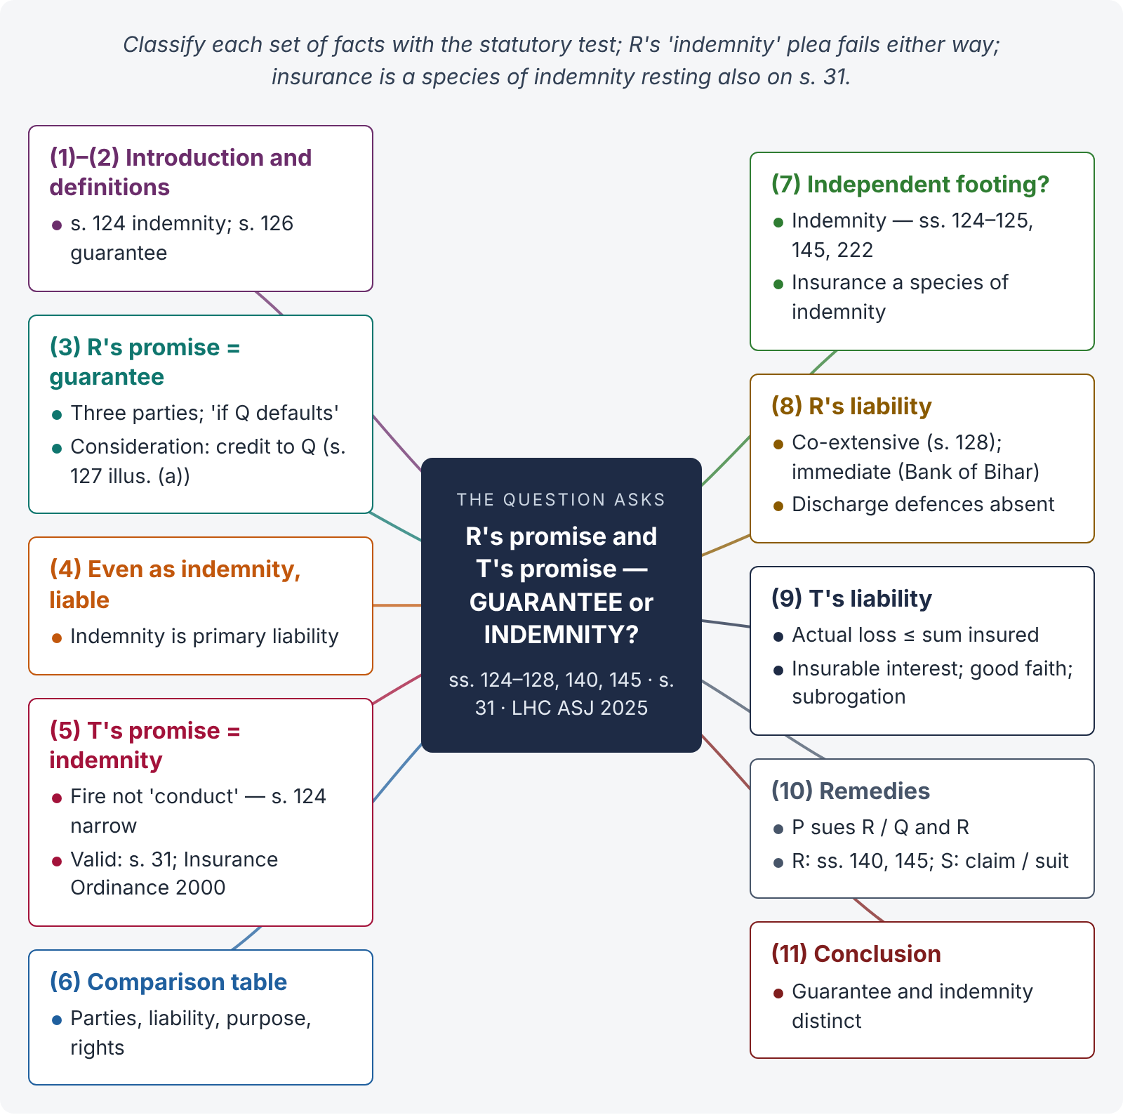
Figure 1 · The answer map: every branch is one numbered heading of the model answer below

Decoding the question
Two sets of facts are placed side by side so that you classify each: R's promise ("if Q defaults, I will pay") is a guarantee (s. 126); T's promise to compensate for fire loss is an indemnity in the form of insurance. Part (b) is conceptual — the place of indemnity and insurance in the Act (the narrow s. 124; insurance as a contingent contract and under the Insurance Ordinance 2000). Part (c) asks for liability and remedies of each. R's argument is a trap: even if his promise were an indemnity, he would be more liable, not less.

The model answer

1. Introduction
Both guarantee and indemnity are contracts to protect a person against loss, and both are contingent contracts (s. 31). But the Contract Act treats them separately: indemnity in s. 124 and guarantee in s. 126. The difference decides who is primarily liable and what rights each party has.

2. The law — definitions
- Indemnity — s. 124: "A contract by which one party promises to save the other from loss caused to him by the conduct of the promisor himself, or by the conduct of any other person, is called a 'contract of indemnity'."
- Guarantee — s. 126: "A 'contract of guarantee' is a contract to perform the promise, or discharge the liability, of a third person in case of his default. The person who gives the guarantee is called the 'surety': the person in respect of whose default the guarantee is given is called the 'principal debtor', and the person to whom the guarantee is given is called the 'creditor'. A guarantee may be either oral or written."

3. R's promise — a guarantee
R promised P that "if Q defaults, he (R) will pay the price". All the elements of s. 126 are present:
- Three parties — P (creditor), Q (principal debtor), R (surety).
- A primary liability of Q to pay the price under the sale on credit.
- R's promise is collateral and conditional on Q's default — a secondary liability.
- Consideration — P's delivery of goods to Q on credit: "anything done … for the benefit of the principal debtor may be a sufficient consideration to the surety" (s. 127; illustration (a) — goods sold on credit on the faith of C's guarantee is exactly this case).
- It is in writing (s. 126 allows oral or written; Art. 17 QSO attestation aids proof).
R's contention that his liability is an indemnity is misconceived. The words "if Q defaults" show a secondary obligation dependent on another's primary debt — the hallmark of guarantee (Birkmyr v. Darnell (1704) 1 Salk 27: "if he does not pay you, I will" is a guarantee; "I will see you paid" is an indemnity).

4. Even if it were an indemnity, R would be liable
An indemnifier's liability is primary and independent (s. 124). If R had promised to save P from loss, he would be liable for P's loss directly, without even the defences a surety has (ss. 133–141). R's argument therefore fails either way: the classification affects the nature of his liability, not its existence.

5. T's promise — indemnity (insurance)
T, an insurer, promised to compensate S for loss due to fire in his warehouse. This is a contract of insurance, which is a contract of indemnity in substance: S is to be restored to the position he was in before the loss.
But note: s. 124 covers loss caused "by the conduct of the promisor himself, or by the conduct of any other person". Loss by accidental fire is not caused by human conduct, so fire insurance falls outside the literal words of s. 124. It is nonetheless a valid contract: (i) a contingent contract (s. 31 — "A contracts to pay B Rs. 10,000 if B's house is burnt" is the Act's own illustration); (ii) governed by the Insurance Ordinance 2000; and (iii) subject to the general principles of indemnity that the courts apply in equity (Adamson v. Jarvis (1827) — the wider English concept).

6. Guarantee and indemnity distinguished on these facts
Point | R's promise (guarantee) | T's promise (indemnity / insurance)
Parties | Three — P, Q, R | Two — S and T
Liability | Secondary, on Q's default | Primary, on the happening of the loss
Existing debt | Q's debt for the price | No debt — a risk of future loss
Purpose | Security for the price | Protection against fire loss
Request | R acts for Q's benefit (usually at Q's request) | T acts on its own account, for a premium
After payment | R steps into P's shoes against Q (s. 140) and is indemnified by Q (s. 145) | T is subrogated to S's rights against any wrongdoer (equity / insurance law)
Consideration | Delivery of goods to Q (s. 127) | Premium paid by S

7. Is indemnity merely a species of insurance or guarantee?
- Indemnity has an independent footing. It is a distinct contract under ss. 124–125, with its own rights for the indemnity-holder (damages, prudent costs and compromises — s. 125). It arises in many contexts besides insurance — e.g., an agent's right to indemnity (ss. 222–223), a principal debtor's implied indemnity to the surety (s. 145), indemnity bonds given to banks for lost cheques or to registrars for duplicate documents.
- Insurance is a species of indemnity, not the other way round — at least fire, marine and property insurance (life insurance is not indemnity, but a contingent contract to pay a fixed sum). Because s. 124 is narrow, insurance rests also on s. 31 and the Insurance Ordinance 2000.
- Guarantee is a separate contract, though related: in a sense it is a special kind of protection against loss, but with three parties and a secondary liability, and it has its own code (ss. 126–147).

8. Scope of R's liability
- Co-extensive with Q's — "The liability of the surety is co-extensive with that of the principal debtor, unless it is otherwise provided by the contract" (s. 128): the unpaid price, and any interest and charges due (illustration to s. 128).
- Immediate — P need not first sue Q or exhaust remedies against him (Bank of Bihar v. Damodar Prasad, AIR 1969 SC 297).
- Defences — R is discharged if P varied the contract with Q without R's consent (s. 133), released Q (s. 134), made a binding agreement to give Q time (s. 135), impaired R's remedy (s. 139), or lost securities (s. 141); and the guarantee is invalid if obtained by P's misrepresentation or concealment (ss. 142–143). None appears on the facts.

9. Scope of T's liability
- Actual loss caused by fire, up to the sum insured — the insured may not profit (principle of indemnity).
- Subject to the policy's terms, conditions and exclusions (e.g., notice of loss, excluded causes).
- Insurable interest — S must have an interest in the warehouse or goods at the time of loss.
- Utmost good faith — non-disclosure of material facts by S may allow T to avoid the policy.
- Subrogation and contribution — on payment, T may claim against anyone responsible for the fire; if other insurers covered the same risk, they contribute rateably.

10. Remedies

i) P
P may sue R alone, or Q and R jointly (O. I r. 3 CPC — Topic 1), for the price with interest and costs. He need not first proceed against Q.

ii) R, on paying P
R is subrogated to all P's rights against Q (s. 140) and may recover from Q all he rightfully paid under the implied indemnity (s. 145), with the benefit of any securities P held (s. 141).

iii) S
S may claim under the policy, and if T repudiates or delays, sue for the amount of the loss (or seek the remedies provided by the Insurance Ordinance 2000, which provides a special forum for insurance claims and compensation for delayed payment). S cannot recover more than his actual loss.

11. Conclusion
R's written promise to pay "if Q defaults" is a guarantee under s. 126, supported by consideration under s. 127; his plea that it is an indemnity is wrong and would not help him anyway. R is liable co-extensively and immediately. T's promise is an indemnity in the form of fire insurance — valid as a contingent contract and under the Insurance Ordinance, and limited to S's actual loss. Indemnity has its own footing in ss. 124–125; insurance is a species of it, and guarantee is a distinct three-party contract.

Why this answer scores
- It classifies each set of facts with the statutory test and Birkmyr v. Darnell — the core of the question.
- It turns R's argument against him (indemnity is primary liability).
- It answers the conceptual part (b) with the narrow s. 124, s. 31 and the Insurance Ordinance.
- It deals with liability and remedies for all four persons.

Answer 2 · The holding company's guarantee — is it valid? Essentials of a guarantee (LHC 2020)
AT A GLANCE · LAHORE HIGH COURT 2020 · CIVIL LAW-I · PART I · Q. 1 · 20 MARKS
A holding company "AZU Limited Company" executed a guarantee of worth Five Hundred Thousand Rupees on behalf of its subsidiary company "AUB Limited Company" via written contract in favor of AKL Bank promising thereby that in case of default by AUB, AZU will discharge the liability. Bank demanded the compliance of the guarantee executed and subsidiary refused to execute it, therefore, Bank asked the guarantor i.e. holding company to fulfill its promise. AZU company also declined to execute the guarantee demanded. In your opinion, explain whether there is a valid contract of guarantee between the parties. Also, explain the importance of the essential elements required for the formation of a valid contract of guarantee.

The answer map
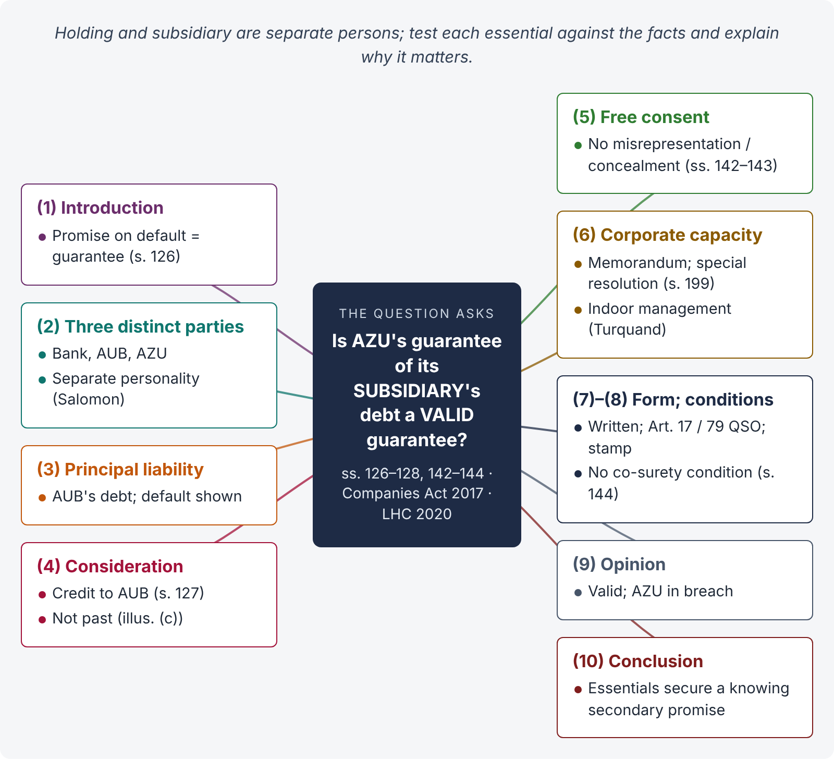
Figure 2 · The answer map: every branch is one numbered heading of the model answer below

Decoding the question
The twist is that the surety is the parent of the debtor. The examiner wants you to see that the holding and subsidiary companies are separate legal persons, so there are genuinely three parties; and to test each essential of a guarantee against the facts — principal liability, consideration, consent, capacity (corporate powers and authority), form and proof. Explain why each essential matters, then give a clear opinion.

The model answer

1. Introduction
A guarantee is "a contract to perform the promise, or discharge the liability, of a third person in case of his default" (s. 126). AZU's written promise to AKL Bank that "in case of default by AUB, AZU will discharge the liability" is, on its face, a classic guarantee. Whether it is valid depends on whether the essentials are satisfied.

2. Essential 1 — three distinct parties
A guarantee needs a creditor, a principal debtor and a surety (s. 126). Here: AKL Bank (creditor), AUB (principal debtor), AZU (surety).
Is a holding company a "third person" in relation to its subsidiary? Yes. A company is a separate legal person from its members, including a parent company that owns its shares (Salomon v. A. Salomon & Co., [1897] AC 22; Companies Act 2017). AZU and AUB are distinct persons; AZU's promise concerns the liability of a third person, AUB. The relationship of holding and subsidiary does not merge them. (Courts "lift the veil" only in cases of fraud or sham — not to defeat a genuine guarantee.)
Importance: without a separate principal debtor, the promise would be a primary obligation (an indemnity or direct debt), and the rules of suretyship would not apply.

3. Essential 2 — a principal liability
A guarantee is collateral to a primary liability. AUB owes, or will owe, the Bank a debt (a loan or facility) — that is the liability guaranteed. Its existence and enforceability matter: if AUB's debt were void (e.g., ultra vires AUB or illegal), there would be nothing to guarantee. The facts show a debt which AUB "refused" to pay — a default, not an absence of liability.
Importance: the surety's liability is co-extensive with the principal's (s. 128); it rises and falls with it.

4. Essential 3 — consideration
"Anything done, or any promise made, for the benefit of the principal debtor may be a sufficient consideration to the surety for giving the guarantee" (s. 127). The Bank's grant of credit to AUB — at AZU's request, or on the faith of AZU's guarantee — is sufficient consideration. AZU need receive nothing itself (though, as parent, it benefits indirectly).
If the guarantee was given after the loan, without any further act or forbearance by the Bank at AZU's request, it would lack consideration (illus. (c) to s. 127). The facts suggest that the guarantee secured the transaction, so the consideration is present.
Importance: without consideration a guarantee is void (s. 25), except where the guarantee is made by a registered deed out of natural love and affection (not relevant to companies).

5. Essential 4 — free consent and good faith
The guarantee is invalid if obtained by the creditor's misrepresentation about a material part of the transaction (s. 142), or by the creditor's silence about material circumstances (s. 143 — e.g., if the Bank knew of AUB's earlier defaults and concealed them). Nothing on the facts suggests misrepresentation or concealment; the burden would be on AZU to prove it.
Importance: the surety takes on another's risk; he must know the true nature of that risk.

6. Essential 5 — capacity and authority of a company
A company can act only within its powers (its memorandum and the Companies Act) and through authorised persons.
- Power to guarantee. The memorandum of a holding company usually authorises it to guarantee the obligations of its subsidiaries. A guarantee ultra vires the company would be void.
- Corporate approval. Under the Companies Act 2017, investments in associated companies — a term that covers guarantees and similar support — generally require approval of the members by special resolution (s. 199). If the required approval was not obtained, AZU may argue the guarantee is unauthorised.
- Authority of signatories. The guarantee must be signed by persons authorised by the board. A bank dealing in good faith may rely on the company's apparent authority (the "indoor management" rule — Royal British Bank v. Turquand (1856) 6 E & B 327), unless the irregularity was apparent.
Importance: capacity is an essential of every contract (ss. 10–11); a company's capacity is defined by statute and its constitution.

7. Essential 6 — form and proof
A guarantee "may be either oral or written" (s. 126). Here it is written, which is the usual practice of banks. As an instrument creating a financial obligation, it should be attested by two men, or one man and two women (Art. 17(2)(a), Qanun-e-Shahadat 1984), and, if denied, proved by calling attesting witnesses (Art. 79). It must also bear proper stamp duty (Stamp Act 1899 — a guarantee is a stamped instrument; an unstamped instrument is inadmissible until the duty and penalty are paid). These go to proof and admissibility, not to the existence of the contract.

8. Essential 7 — no condition precedent unfulfilled
If AZU had given the guarantee on condition that a co-surety (e.g., a director's personal guarantee) would join, and he did not, the guarantee would be invalid (s. 144). No such condition appears.

9. Application — the opinion
- AKL Bank, AUB and AZU are three separate persons; the promise is to discharge AUB's liability on default — a guarantee (s. 126).
- The credit given to AUB is consideration (s. 127).
- There is no indication of misrepresentation, concealment, or an unfulfilled condition (ss. 142–144).
- Subject to AZU's corporate power and approval (memorandum; Companies Act 2017, s. 199) and the authority of its signatories (protected for a bona fide bank by the indoor management rule), the guarantee is valid.
- AUB has defaulted ("refused"); AZU's liability has therefore arisen. AZU's refusal is a breach of the guarantee.

10. Conclusion
There is a valid contract of guarantee between AKL Bank and AZU for AUB's liability up to Rs. 500,000. The essentials — three distinct parties, a principal liability, consideration, free consent, capacity, and proper form — each serve a purpose: they ensure that the surety knowingly undertakes a secondary obligation, for value, for a real debt of another. AZU's only possible escape lies in corporate-law defects (lack of power or approval), which a bank dealing in good faith can usually meet.

Why this answer scores
- It spots the separate legal personality point, which the "holding company" facts are designed to test (Salomon).
- Each essential has a heading, the statutory basis, an application and an "importance" line — exactly what the question asks.
- It adds company-law and evidence dimensions (s. 199 Companies Act 2017; Art. 17 QSO; stamp duty) that a judicial examiner expects.
- It gives a clear opinion, with the only realistic defence identified.

Answer 3 · Advising the bank — options for enforcing the guarantee and the guarantor's liability (LHC 2020)
AT A GLANCE · LAHORE HIGH COURT 2020 · CIVIL LAW-I · PART I · Q. 2 · 20 MARKS
(On the same facts as Answer 2.) Write an opinion advising the Bank on the various possible option(s) available for the enforcement of the contract of guarantee along with the liability of the guarantor.

The answer map
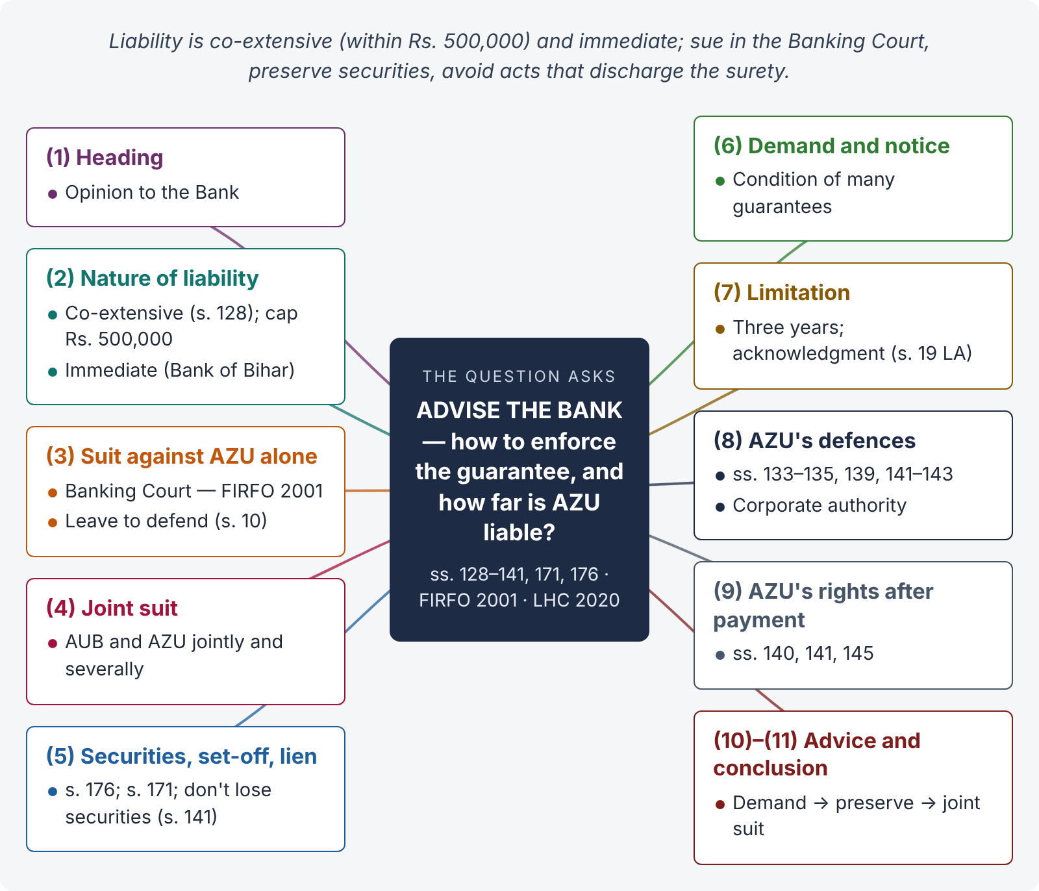
Figure 3 · The answer map: every branch is one numbered heading of the model answer below

Decoding the question
An opinion to a client — so write it in that form (to, from, facts, advice). Cover: the nature and extent of AZU's liability (s. 128, the Rs. 500,000 cap, immediacy); the forum — a bank's recovery suit lies to the Banking Court under the Financial Institutions (Recovery of Finances) Ordinance 2001; the options (sue AZU alone, sue both, enforce securities, set-off and banker's lien, demand under the guarantee); the defences AZU may raise (discharge — ss. 133–139, 141); and practical steps (notice of demand, limitation).

The model answer

1. Heading
To: The Manager, AKL Bank. Subject: Enforcement of AZU Limited's guarantee of AUB Limited's liability (Rs. 500,000). Facts: AUB has defaulted; AZU, the guarantor, has refused your demand.

2. The nature of AZU's liability
- Co-extensive — "The liability of the surety is co-extensive with that of the principal debtor, unless it is otherwise provided by the contract" (s. 128). AZU is liable for AUB's debt with interest and charges (illustration to s. 128) — but not beyond the limit of Rs. 500,000 fixed in the guarantee (plus costs, and interest on its own default if the guarantee so provides).
- Immediate — AZU's liability arose on AUB's default. The Bank is not bound to sue AUB first or exhaust remedies against it (Bank of Bihar v. Damodar Prasad, AIR 1969 SC 297: "the very object of the guarantee is defeated if the creditor is asked to postpone his remedies against the surety").
- Separate contract — the guarantee is a contract between the Bank and AZU; AZU cannot rely on any internal arrangement with AUB (s. 132 principle).
- Continuing or specific? If the guarantee covers a running facility ("all sums from time to time due"), it is continuing (s. 129); AZU may revoke it for the future by notice (s. 130), but remains liable for what was already advanced.

3. Option 1 — a recovery suit against AZU alone
The Bank may sue AZU alone on the guarantee. Since AKL Bank is a "financial institution" and the claim arises from a finance and a guarantee for it, the suit lies to the Banking Court under the Financial Institutions (Recovery of Finances) Ordinance 2001, which has exclusive jurisdiction over such claims against a customer — a term that includes a surety or guarantor of the finance. Under that Ordinance:
- the plaint must be supported by a statement of account and the documents relied on;
- the defendant may defend only with leave, by an application for leave to defend raising substantial questions (s. 10) — otherwise a decree follows;
- the decree is executed by the Banking Court, which has wide powers (including sale of mortgaged or pledged property).
(If the Bank were not a financial institution, the suit would be an ordinary recovery suit, or a summary suit under O. XXXVII CPC if based on a negotiable instrument — Topic 2.)

4. Option 2 — a suit against AUB and AZU jointly
The Bank may join AUB and AZU as defendants (O. I r. 3 CPC) and obtain a decree against both, jointly and severally. It can then execute against either. This is often the best option: one suit, one decree, full security.

5. Option 3 — enforce securities, set-off and the banker's lien
- Securities — if AUB or AZU gave any pledge, mortgage or hypothecation, the Bank may enforce it (pledge — sale on reasonable notice, s. 176).
- Banker's general lien — a banker may retain, as security for a general balance of account, goods and securities bailed to it (s. 171).
- Set-off / combination of accounts — if AZU keeps a credit balance with the Bank and the guarantee permits, the Bank may set it off against AZU's liability once due.
- Caution: the Bank must not release or lose any security held when the guarantee was given, or AZU will be discharged to that extent (s. 141).

6. Option 4 — a demand under the guarantee and notice
Before suing, the Bank should serve a written demand on AZU in the manner the guarantee requires (many guarantees make a written demand a condition of liability), and a legal notice. A demand also fixes the date from which interest for default may run and starts limitation where the guarantee makes payment due "on demand".

7. Limitation
A suit on a guarantee is governed by the Limitation Act 1908 — generally three years, running from the date of default / demand (depending on the terms of the guarantee). The Bank should act promptly; an acknowledgment in writing by AZU within the period gives a fresh period (s. 19, Limitation Act).

8. Defences AZU may raise — and how to meet them
Defence | Advice
Variance in AUB's facility without AZU's consent (s. 133) | Check whether limits, rates or terms were changed after the guarantee; most bank guarantees contain AZU's advance consent to variations.
Release of AUB, composition, binding time (ss. 134–135) | Do not enter into a settlement or rescheduling with AUB without AZU's written consent. Mere delay in suing AUB (s. 137) does not discharge AZU.
Creditor impaired AZU's remedy (s. 139); lost securities (s. 141) | Preserve all securities; do not release them without AZU's consent.
Misrepresentation or concealment (ss. 142–143) | Keep records showing what AZU was told; disclose unusual facts about AUB.
Ultra vires / no corporate approval | Produce the board resolution and members' approval (Companies Act 2017); rely on the indoor management rule (Turquand).
Limit of liability | Claim within the Rs. 500,000 cap plus costs and contractual interest.

9. AZU's rights after payment
The Bank should be aware that, once AZU pays, AZU is subrogated to the Bank's rights against AUB (s. 140), is entitled to the Bank's securities (s. 141), and may recover from AUB under the implied indemnity (s. 145). The Bank should therefore be ready to assign the securities to AZU on full payment.

10. Advice in summary
- Serve a written demand under the guarantee on AZU (and AUB).
- Preserve all securities; make no arrangement with AUB without AZU's consent.
- File a recovery suit in the Banking Court under the FIRFO 2001 against AUB and AZU jointly and severally for the amount due, limited as against AZU to Rs. 500,000 plus costs.
- Meanwhile, exercise any set-off or lien available (s. 171).
- Oppose any application for leave to defend that raises only the defences above, which are not made out on the facts.

11. Conclusion
AZU's liability is co-extensive with AUB's (within the Rs. 500,000 limit) and immediate. The Bank may proceed against AZU without first suing AUB, preferably by a joint recovery suit in the Banking Court, while preserving its securities and avoiding any variance or release that could discharge the guarantor.

Why this answer scores
- It is written as an opinion with practical steps — what the question asks for.
- It states the extent and immediacy of liability with s. 128 and Bank of Bihar.
- It identifies the right forum (Banking Court under FIRFO 2001), which separates a judicial candidate from an LL.B answer.
- It anticipates AZU's defences (ss. 133–144) and tells the Bank how to avoid them.

Answer 4 · Rights of the surety, and when the surety is discharged (PU LL.B)
AT A GLANCE · PUNJAB UNIVERSITY LL.B PART III · LAW OF CONTRACT · 2019 (ANNUAL) Q. 4 AND 2019 (SUPPLEMENTARY) Q. 7 · 20 MARKS
Define guarantee. What are the rights of a surety? · Define indemnity and guarantee. When is a surety discharged from liability?

The answer map
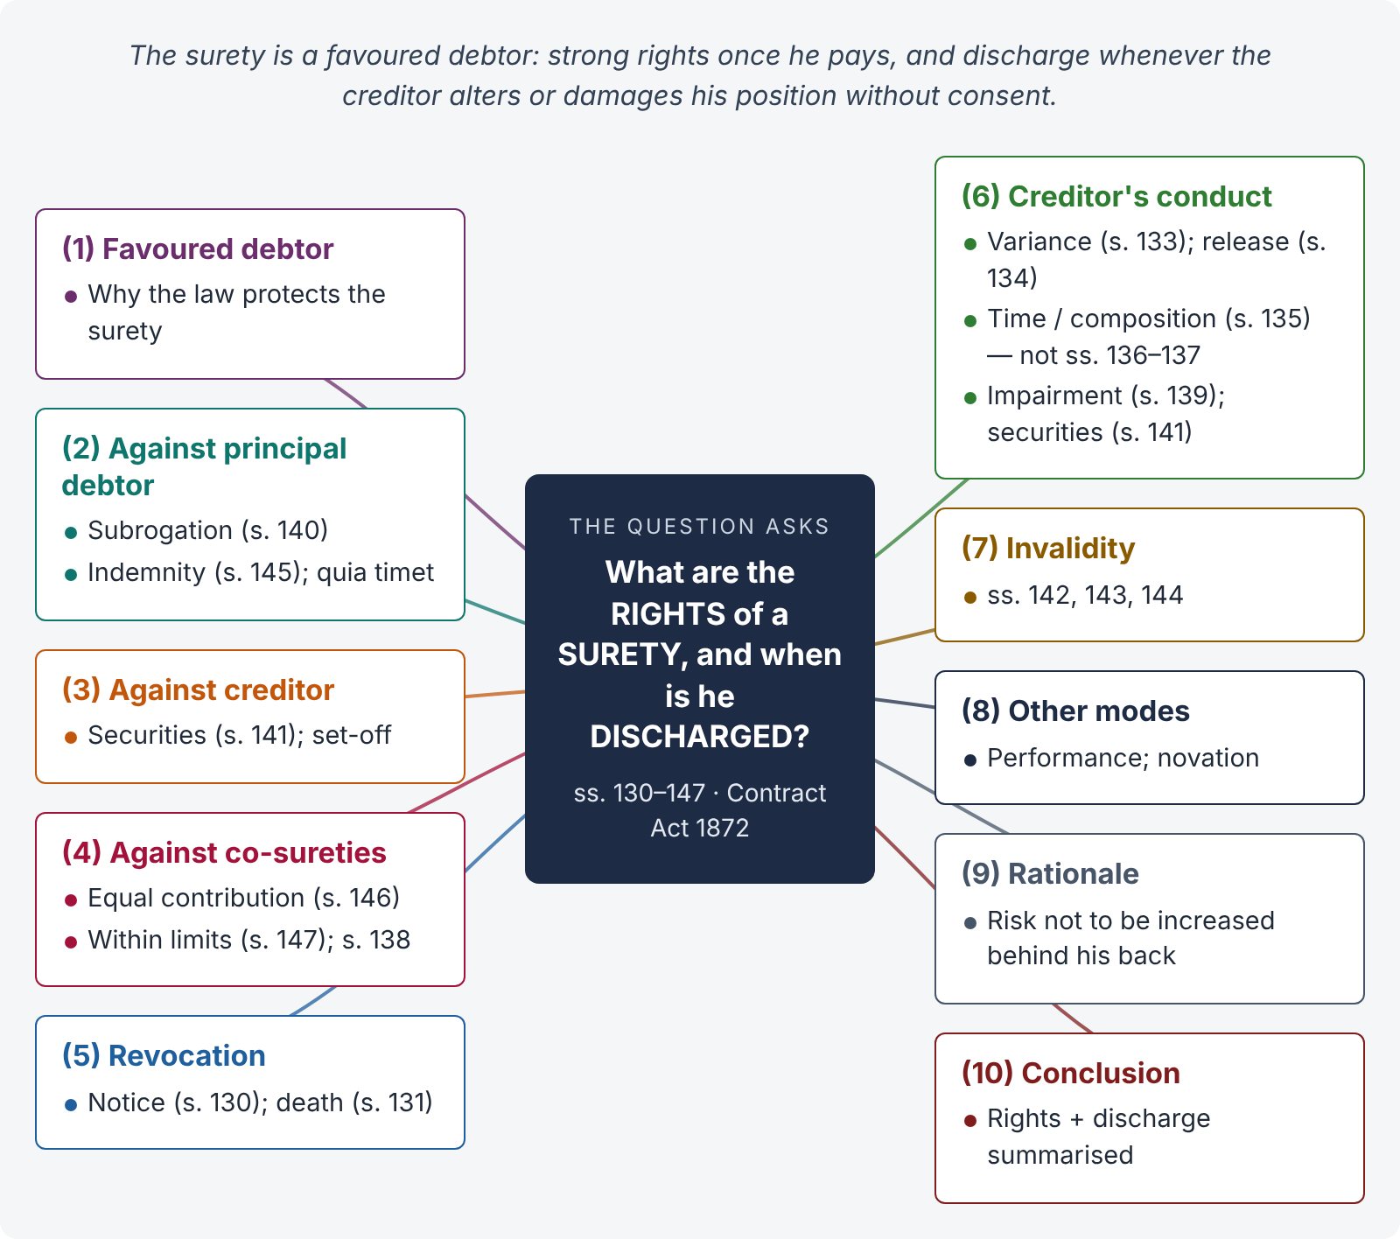
Figure 4 · The answer map: every branch is one numbered heading of the model answer below

Decoding the question
A two-part theory question: rights of the surety (against the principal debtor, the creditor and co-sureties) and discharge (by revocation, by the creditor's conduct, by invalidity). Quote the sections and their illustrations, which are almost all the authority you need, and give the rationale: the surety is a "favoured debtor" whose risk must not be increased behind his back.

The model answer

1. Introduction — the surety as a favoured debtor
A guarantee is a contract to perform the promise, or discharge the liability, of a third person on default (s. 126). The surety receives nothing for himself; he helps the principal debtor obtain credit. The law therefore protects him: it gives him strong rights once he pays, and discharges him if the creditor changes or damages his position without his consent.

2. Rights against the principal debtor
- Subrogation — s. 140. On payment or performance of all that he is liable for, the surety "is invested with all the rights which the creditor had against the principal debtor" — including securities, priorities and decrees.
- Indemnity — s. 145. "In every contract of guarantee there is an implied promise by the principal debtor to indemnify the surety; and the surety is entitled to recover from the principal debtor whatever sum he has rightfully paid under the guarantee, but no sums which he has paid wrongfully." Illus. (a): reasonable defence costs recoverable; (b): costs of a groundless defence not recoverable; (c): only the price of goods actually supplied.
- Quia timet — once the debt is due, the surety may ask the court to direct the principal debtor to pay the creditor and relieve him.

3. Rights against the creditor
- Benefit of securities — s. 141. The surety is entitled to every security which the creditor has at the time of the guarantee, whether he knows of it or not; if the creditor loses it or parts with it without the surety's consent, the surety is discharged to the extent of its value. Illus. (a): cancelling a mortgage of the debtor's furniture; (b): withdrawing execution — surety discharged; (c): giving up a security taken later — not discharged.
- Set-off — the surety may set off any claim the principal debtor (or he himself) has against the creditor.
- Discharge in the circumstances of ss. 133–139 (below).
- Not to be sued for more than the principal debtor owes (s. 128) or beyond the limit of the guarantee.

4. Rights against co-sureties
- Equal contribution — s. 146. Co-sureties for the same debt, "either jointly or severally, and whether under the same or different contracts, and whether with or without the knowledge of each other", contribute equally, unless otherwise agreed. Illus. (a): Rs. 3,000 — Rs. 1,000 each; (b): agreed shares one-quarter, one-quarter, one-half — Rs. 250, 250, 500.
- Different sums — s. 147. Co-sureties bound in different sums pay equally as far as their limits permit. Illus.: A (Rs. 10,000), B (Rs. 20,000), C (Rs. 40,000): on a Rs. 30,000 default — Rs. 10,000 each; on Rs. 40,000 — A 10,000, B and C 15,000 each; on Rs. 70,000 — each his full limit.
- Release of one — does not discharge the others or free the released surety from contribution (s. 138).

5. Discharge by revocation (continuing guarantees)
- Notice — s. 130: "A continuing guarantee may at any time be revoked by the surety, as to future transactions, by notice to the creditor." He remains liable for past transactions (illus. (a), (b)).
- Death — s. 131: the surety's death revokes a continuing guarantee as to future transactions, unless otherwise agreed.

6. Discharge by the creditor's conduct
s. | Ground | Illustration / note
133 | Variance in the terms between creditor and principal debtor without the surety's consent — as to later transactions | Bank manager's duties changed (a); clerk moved from salary to commission (c); loan paid two months early (e).
134 | Release of the principal debtor, or any act or omission of the creditor that discharges him | Composition with creditors (a); creditor diverts the stream needed for the crop (b); fails to supply timber (c).
135 | Composition, promise to give time, or promise not to sue the principal debtor — unless the surety assents | A binding agreement with the debtor.
136 | — not where the agreement to give time is with a third person | Holder of a bill agrees with M to give time to B — surety not discharged.
137 | — not by mere forbearance to sue | Creditor waits a year — surety not discharged.
139 | Creditor's act inconsistent with the surety's rights, or omission of a duty to the surety, impairing the surety's eventual remedy | Prepayment of instalments to a shipbuilder (a); negligent sale of security (b); failure to check the apprentice's cash monthly (c).
141 | Loss or parting with securities | Discharged to the value of the security.

7. Discharge by invalidity of the guarantee
- Misrepresentation by the creditor (or with his knowledge) about a material part of the transaction — invalid (s. 142).
- Concealment — keeping silence as to material circumstances — invalid (s. 143; illus. (a): clerk's earlier defaults concealed; (b): secret overcharge to clear an old debt).
- Co-surety who was to join does not join — invalid (s. 144).

8. Other modes of discharge
- Performance — payment by the principal debtor or the surety.
- Novation of the principal contract (s. 62) — the old debt, and the guarantee, end.
- Discharge of the principal debt by the creditor's act (s. 134). But discharge of the principal debtor by operation of law (e.g., insolvency) does not discharge the surety.

9. Rationale
The surety agreed to bear a defined risk. The creditor may not, without the surety's consent, increase that risk (variance, giving time), destroy the surety's recourse (release, loss of securities, impairment), or obtain the guarantee by deceit (misrepresentation, concealment). Each rule protects the surety's eventual right to recover from the principal debtor.

10. Conclusion
A surety who pays steps into the creditor's shoes (s. 140), takes the benefit of every security (s. 141), recovers from the principal debtor (s. 145), and shares the burden equally with co-sureties (ss. 146–147). He is discharged by revocation of a continuing guarantee (ss. 130–131), by variance, release, binding time or impairment of his remedy (ss. 133–139), by loss of securities (s. 141), and where the guarantee was obtained by misrepresentation or concealment (ss. 142–144) — but not by mere forbearance or by the release of a co-surety.

Why this answer scores
- It organises the surety's rights by against whom they lie — a structure examiners reward.
- The discharge table collects ss. 133–141 with the statutory illustrations.
- It marks the exceptions that catch weak candidates (ss. 136, 137, 138).
- The rationale section shows understanding, not memory alone.

Answer 5 · Bailment, bailor and bailee — the obligations of each (LHC 2023)
AT A GLANCE · LAHORE HIGH COURT 2023 · CIVIL LAW-I · Q. 2 · 20 MARKS
Define expressions 'Bailment', 'Bailor', and 'Bailee'. Illustrate the respective obligations of 'Bailor' and 'Bailee' as discussed in the Contract Act.

The answer map
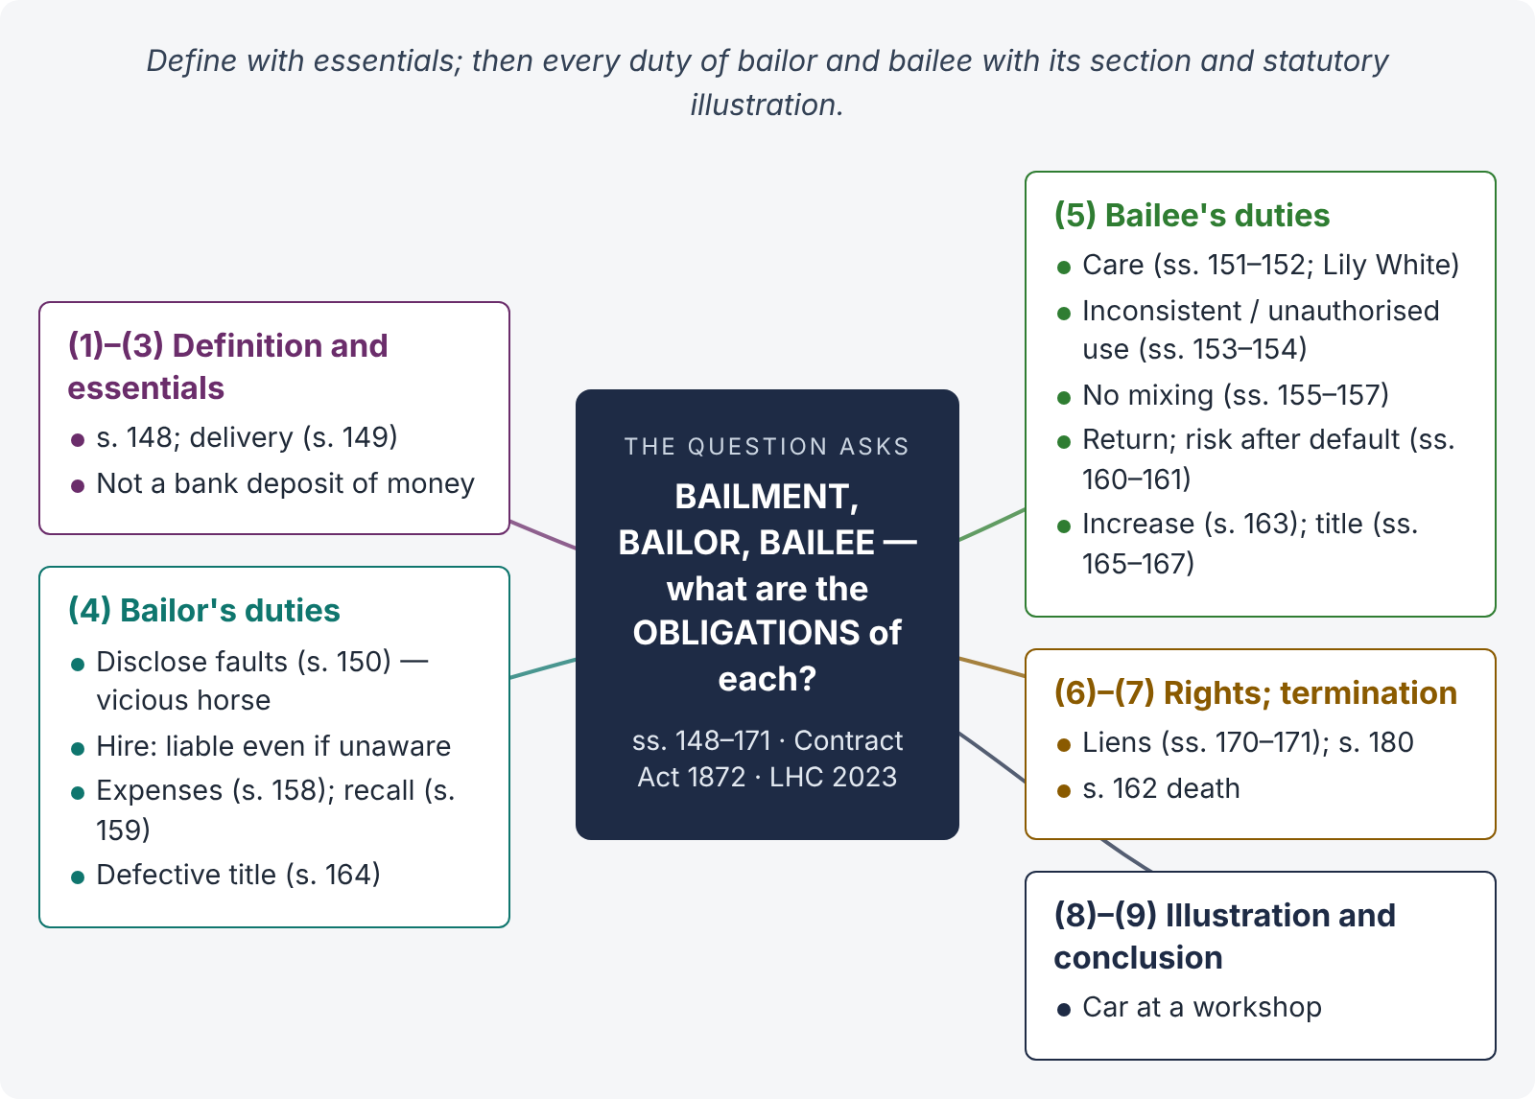
Figure 5 · The answer map: every branch is one numbered heading of the model answer below

Decoding the question
"Define" — s. 148 with its essentials and what is not bailment. "Illustrate the respective obligations" — every duty of the bailor (ss. 150, 158, 159, 164) and of the bailee (ss. 151–157, 160–163, 165–167), each with the statutory illustration. A short note on the bailee's rights (lien) rounds off the answer.

The model answer

1. Introduction
Bailment is one of the most common contracts of daily life — the car left at a workshop, clothes at a laundry, goods in a warehouse, a book lent to a friend. Chapter IX of the Contract Act (ss. 148–181) lays down the duties and rights of the parties.

2. Definitions — s. 148
"A 'bailment' is the delivery of goods by one person to another for some purpose, upon a contract that they shall, when the purpose is accomplished, be returned or otherwise disposed of according to the directions of the person delivering them. The person delivering the goods is called the 'bailor'. The person to whom they are delivered is called the 'bailee'." By the Explanation, a person already in possession who contracts to hold as bailee becomes a bailee.

3. Essentials
- Goods — movables only.
- Delivery of possession — actual or constructive (s. 149); ownership stays with the bailor.
- Purpose — custody, repair, carriage, use, security.
- Contract — express or implied (by law for finders — s. 71; State seizures — State of Gujarat v. Memon Mahomed Haji Hasam, AIR 1967 SC 1885).
- Return of the same goods, or disposal as directed.
Not bailment: a deposit of money in a bank (the bank need not return the same notes); a sale; a servant's custody of his master's goods.

4. Duties of the bailor

i) To disclose known faults — s. 150
The bailor must disclose faults he is aware of which materially interfere with use or expose the bailee to extraordinary risks; otherwise he is liable for damage arising directly from them. Illus. (a): A lends a horse he knows to be vicious — liable for B's injury.

ii) In bailment for hire — liability even for unknown faults — s. 150 (second para.)
"If the goods are bailed for hire, the bailor is responsible for such damage, whether he was or was not aware of the existence of such faults." Illus. (b): A hires an unsafe carriage from B, who does not know of the defect — B is liable.

iii) To repay necessary expenses in gratuitous bailment — s. 158
Where the bailee receives no remuneration, the bailor must repay necessary expenses incurred for the bailment.

iv) To indemnify for early recall of a gratuitous loan — s. 159
The lender may recall a gratuitous loan at any time, but if the borrower, acting on the loan for a specified time, would suffer loss exceeding the benefit derived, the lender must indemnify him for the excess.

v) To indemnify for defective title — s. 164
The bailor is responsible for any loss the bailee suffers because the bailor was not entitled to make the bailment, receive back the goods or give directions.

vi) To receive back the goods
The bailor must take back the goods when the purpose is accomplished (otherwise the bailee may claim reasonable charges for custody).

5. Duties of the bailee

i) To take reasonable care — ss. 151, 152
The bailee must take "as much care of the goods bailed to him as a man of ordinary prudence would, under similar circumstances, take of his own goods of the same bulk, quality and value" (s. 151). If he does, he is not responsible for loss, destruction or deterioration, in the absence of a special contract (s. 152). The standard is the same in all bailments, gratuitous or for reward. A clause attempting to reduce liability below this standard has been held invalid (Lily White v. R. Munuswami, AIR 1966 Mad 13 — laundry's "50 % of value" clause).

ii) Not to act inconsistently with the conditions — s. 153
The bailment becomes voidable at the bailor's option. Illus.: a horse hired for B's own riding is driven in his carriage — A may terminate.

iii) Not to make unauthorised use — s. 154
The bailee is liable for any damage arising from or during unauthorised use, even without negligence. Illus. (a): a horse lent for B's own riding is ridden carefully by C, who is a member of B's family, and falls by accident — B is liable. Illus. (b): a horse hired in Karachi to go to Hyderabad is taken to Khairpur and falls — A is liable.

iv) Not to mix the goods with his own — ss. 155–157
With consent — proportionate interest (s. 155). Without consent, separable — the bailee bears separation costs and damage (s. 156; illus.: 100 marked bales of cotton). Without consent, inseparable — the bailee must compensate (s. 157; illus.: Cape flour worth Rs. 45 mixed with country flour worth Rs. 25).

v) To return the goods — s. 160
"It is the duty of the bailee to return, or deliver according to the bailor's directions, the goods bailed, without demand, as soon as the time … has expired, or the purpose … has been accomplished."

vi) Liability for failure to return in time — s. 161
If, by his default, the goods are not returned at the proper time, he is responsible for any loss, destruction or deterioration from that time — even by accident (Shaw & Co. v. Symmons & Sons, [1917] 1 KB 799 — books destroyed by fire after the bookbinder failed to return them in time).

vii) To deliver any increase or profit — s. 163
Illus.: a cow left with B has a calf — B must deliver both.

viii) Not to deny the bailor's title, and to deal properly with competing claims
The bailee is estopped from denying the bailor's title (Art. 115 QSO principle). But he may return the goods to one joint owner (s. 165); is protected if he returns them in good faith to a bailor without title (s. 166); and where a third person claims them, that person may apply to the court to stop delivery and decide title (s. 167).

6. Rights of the bailee (in brief)
- Particular lien for labour or skill on the goods (s. 170; illus. (a): the jeweller who cuts a diamond; (b): not the tailor who gave credit).
- General lien for bankers, factors, wharfingers, High Court attorneys and policy-brokers (s. 171).
- Compensation under ss. 150, 159, 164; expenses under s. 158.
- Suit against wrongdoers (s. 180), with apportionment (s. 181).

7. Termination of bailment
On expiry of the time or accomplishment of the purpose (s. 160); at the bailor's option on inconsistent use (s. 153); on recall of a gratuitous loan (s. 159); on the death of either party in a gratuitous bailment (s. 162); and on destruction of the goods.

8. Illustration
Hassan leaves his car at Ahmed Motors, I-9, for a service, for a fee. Ahmed is a bailee for reward. He must keep the car with ordinary prudence (s. 151) — e.g., lock it inside the workshop at night; he must not use it for his own errands (s. 154); he must return it when the service is done (s. 160); and he has a particular lien for his service charges (s. 170). If the car is stolen from the open street because Ahmed left it unlocked, he is liable; if it is stolen in an armed robbery of a properly secured workshop, he is not (s. 152).

9. Conclusion
Bailment is the delivery of goods for a purpose on a contract to return them (s. 148). The bailor must disclose faults (strictly, if for hire), repay expenses in gratuitous bailments, indemnify on early recall and for defective title. The bailee must take the care of a prudent man, avoid unauthorised use and mixing, return the goods with any increase on time, and respect the bailor's title. These reciprocal duties keep the goods safe while they are in another's hands.

Why this answer scores
- Definitions and essentials first, with what is not bailment — clarity for the examiner.
- Every duty has its section and statutory illustration, as "illustrate" requires.
- It notes the strict liabilities (s. 150 for hire; s. 154 unauthorised use; s. 161 after default) — points weak answers miss.
- A brief note on rights and termination completes the picture without drifting.

Answer 6 · Express and implied authority of an agent; s. 215 — agent dealing on his own account (LHC 2023)
AT A GLANCE · LAHORE HIGH COURT 2023 · CIVIL LAW-I · Q. 1 · 20 MARKS
What do the 'express' and 'implied' authority of an agent mean? Explain factors and circumstances where the authority of the agent is said to be implied. Discuss the circumstances envisaged by section 215 of the Contract Act, where the principal may repudiate the transaction undertaken by the agent, dealing on his own account in the business of the agency.

The answer map
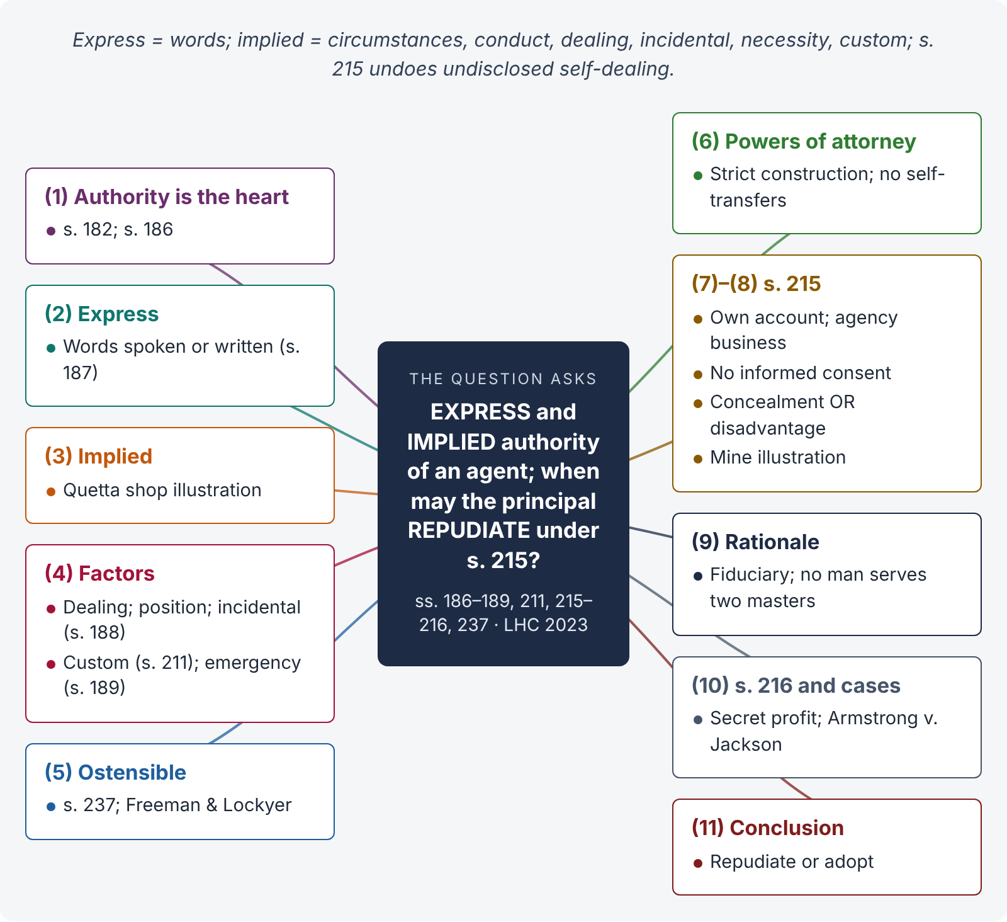
Figure 6 · The answer map: every branch is one numbered heading of the model answer below

Decoding the question
Three parts: (i) definitions of express and implied authority (ss. 186–187); (ii) the factors from which authority is implied — the circumstances, conduct, course of dealing, incidental authority (s. 188), emergency (s. 189), custom (s. 211), and the related ostensible authority (s. 237); (iii) s. 215 — its conditions, the two alternative grounds for repudiation, the illustrations and the related s. 216. Pakistani practice on powers of attorney adds value.

The model answer

1. Introduction — authority is the heart of agency
An agent is "a person employed to do any act for another or to represent another in dealings with third persons" (s. 182). The principal is bound only by acts within the agent's authority. "The authority of an agent may be expressed or implied" (s. 186).

2. Express authority — s. 187
"An authority is said to be express when it is given by words spoken or written." Examples: a power of attorney authorising the attorney to sell a plot; a letter appointing a distributor; an oral instruction to buy shares. Its extent is found by construing the words.

3. Implied authority — s. 187
"An authority is said to be implied when it is to be inferred from the circumstances of the case; and things spoken or written, or the ordinary course of dealing, may be accounted circumstances of the case."
Illustration: A owns a shop in Quetta, lives in Karachi, and visits occasionally. The shop is managed by B, who habitually orders goods from C in A's name and pays for them out of A's funds with A's knowledge. B has an implied authority to order goods from C in A's name for the shop.

4. Factors and circumstances from which authority is implied
- Course of dealing — repeated conduct known to and accepted by the principal (the Quetta illustration).
- Position or relationship — a manager, a partner (Partnership Act), a wife managing the household (authority to buy necessaries on the husband's credit), a master of a ship.
- Incidental authority — s. 188. An agent authorised to do an act may do "every lawful thing which is necessary" for it; an agent to carry on a business may do "every lawful thing necessary for the purpose, or usually done in the course of conducting such business". Illus. (a): an agent to recover a debt at Karachi may take legal proceedings and give a discharge; (b): an agent to run a shipbuilding business may buy timber and hire workmen.
- Custom and usage — authority according to the custom of the trade at the place (s. 211; illus. (b): a broker in a cash-only trade may not sell on credit).
- Emergency — s. 189. In an emergency, an agent may do all acts a prudent man would do to protect his principal from loss. Illus. (b): provisions consigned from Lahore to Rawalpindi may be sold at Lahore if they will not survive the journey (Great Northern Railway v. Swaffield (1874) LR 9 Ex 132).
- Ratification of past acts may imply authority for similar future acts (ss. 196–197).

5. Ostensible (apparent) authority — s. 237
Closely related is ostensible authority: where the principal "by his words or conduct" has induced third persons to believe that the agent's acts were within his authority, the principal is bound, even if he had secretly limited it (s. 237; illus. (a): goods sold below a secret reserve price; Freeman & Lockyer v. Buckhurst Park Properties, [1964] 2 QB 480). Implied authority is real authority inferred between principal and agent; ostensible authority is authority as it appears to the third party.

6. Construction of powers of attorney
Express authority in a power of attorney is construed strictly. An attorney may do only what is clearly authorised and what is necessary to do it (s. 188). Pakistani superior courts have repeatedly refused to uphold transactions in which attorneys transferred the principal's property to themselves or their close relatives without the principal's informed consent (see, e.g., Fida Muhammad v. Pir Muhammad Khan, PLD 1985 SC 341) — which leads directly to s. 215.

7. Section 215 — the text
"If an agent deals on his own account in the business of the agency, without first obtaining the consent of his principal and acquainting him with all material circumstances which have come to his own knowledge on the subject, the principal may repudiate the transaction, if the case shows either that any material fact has been dishonestly concealed from him by the agent, or that the dealings of the agent have been disadvantageous to him."

8. Circumstances in which the principal may repudiate
- The agent deals on his own account — directly, or through a nominee or relative (illus. (a): B buys the estate "in the name of C").
- The dealing is in the business of the agency (he was employed to sell, and buys; employed to buy, and sells his own goods).
- He did so without first obtaining the principal's consent after disclosing all material circumstances known to him.
- Either (a) a material fact was dishonestly concealed (illus. (b): B finds a mine on the estate, conceals it, and buys with A's permission — A may repudiate or adopt), or (b) the dealing was disadvantageous to the principal (e.g., a sale below market value).
Consent obtained without full disclosure is no consent for this purpose (illus. (b)).

9. Rationale
An agent is a fiduciary. As seller for the principal he should get the highest price; as buyer for himself he wants the lowest. "No man can serve two masters." Section 215 removes the temptation by allowing the principal to undo self-dealing unless it was fully disclosed and consented to.

10. Related remedies — s. 216 and case law
- s. 216 — the principal may claim any benefit the agent derived from dealing on his own account (illus.: B tells A the house cannot be bought and buys it himself — A may compel B to sell it to him at cost).
- Armstrong v. Jackson ([1917] 2 KB 822) — a broker instructed to buy shares sold the client his own shares; the client rescinded and recovered the price.
- The principal may alternatively affirm the transaction (illus. (b) — "repudiate or adopt").

11. Conclusion
Express authority is given in words; implied authority is inferred from the circumstances, conduct, course of dealing, position, necessity, custom and the incidental needs of the task (ss. 186–189, 211). Where an agent turns his position to his own account — buying or selling for himself in the business of the agency without informed consent — s. 215 allows the principal to repudiate the transaction if a material fact was dishonestly concealed or the dealing was disadvantageous, and s. 216 lets him claim the profit.

Why this answer scores
- It quotes ss. 186–188 and 215 and uses the Quetta and mine illustrations from the Pakistani text.
- The "factors" part is answered with a numbered list of sources of implied authority, as asked.
- It distinguishes implied from ostensible authority — a refinement examiners notice.
- It sets out the elements of s. 215, its rationale, and the companion remedy in s. 216.

Answer 7 · Modes of creation and termination of agency (PU LL.B)
AT A GLANCE · PUNJAB UNIVERSITY LL.B PART III · LAW OF CONTRACT · 2018 (SUPPLEMENTARY) · Q. 8 · 20 MARKS
What are the different modes of creation and termination of agency?

The answer map
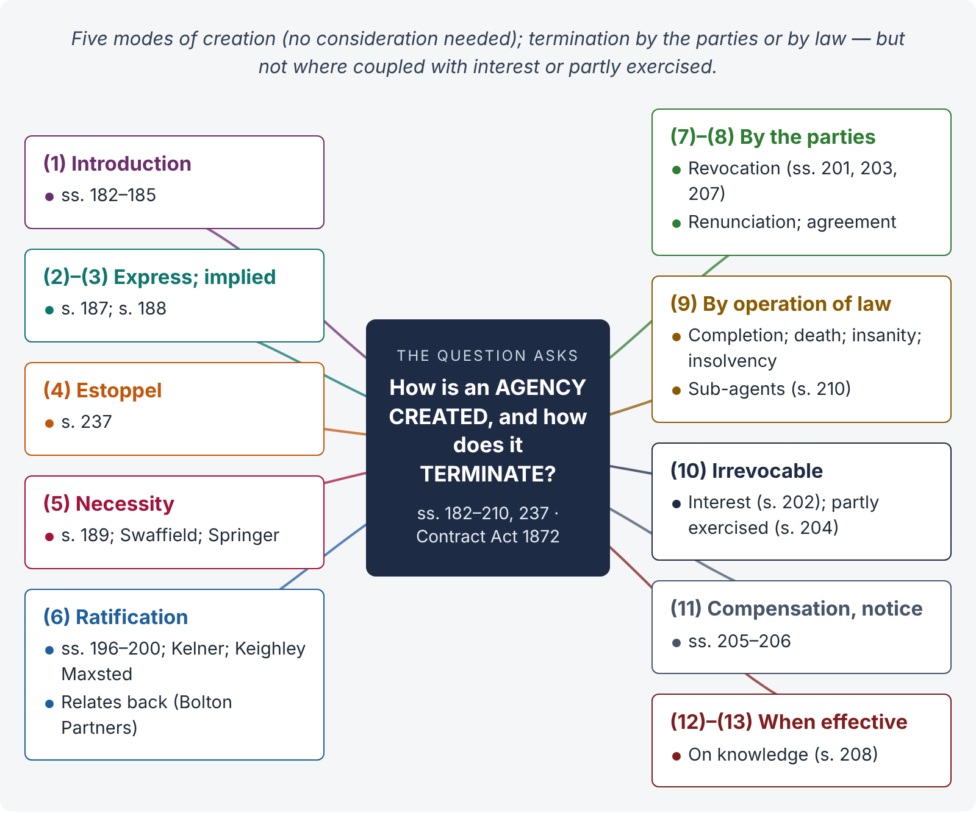
Figure 7 · The answer map: every branch is one numbered heading of the model answer below

Decoding the question
Two lists, each with sections, illustrations and a case: creation — express, implied, estoppel, necessity, ratification (with its conditions); termination — by act of the parties and by operation of law, plus irrevocable agency (s. 202, s. 204), compensation and notice (ss. 205–206) and when termination takes effect (s. 208).

The model answer

1. Introduction
An agent is "a person employed to do any act for another or to represent another in dealings with third persons" (s. 182). Any adult of sound mind may employ an agent (s. 183); any person may be an agent as regards third persons (s. 184); and no consideration is needed (s. 185).

2. Creation (1) — express agency
By words spoken or written (s. 187) — e.g., a power of attorney under the Powers of Attorney Act 1882. Construed strictly.

3. Creation (2) — implied agency
Inferred from the circumstances, conduct or course of dealing (s. 187 — the Quetta shop illustration); including incidental authority (s. 188) and agency arising from relationships (a wife's authority to buy necessaries; partners in a firm).

4. Creation (3) — agency by estoppel
Where the principal by words or conduct induces third persons to believe that someone is his agent, he is bound (s. 237; illus. (a) — secret reserve price; Freeman & Lockyer v. Buckhurst Park Properties, [1964] 2 QB 480).

5. Creation (4) — agency by necessity
In an emergency, an agent may do what a prudent man would do to protect the principal from loss (s. 189 — perishable provisions sold at Lahore). Conditions: real emergency; impossibility of communicating with the principal (Springer v. Great Western Railway, [1921] 1 KB 257); good faith; reasonable action (Great Northern Railway v. Swaffield (1874) LR 9 Ex 132).

6. Creation (5) — agency by ratification
A person may ratify acts done on his behalf without authority, with the same effect as if authorised (s. 196). Conditions:
- the act was done on behalf of the principal, who was in existence and competent at the time (Kelner v. Baxter (1866) — no ratification of pre-incorporation contracts; Keighley, Maxsted & Co. v. Durant, [1901] AC 240 — undisclosed principal cannot ratify);
- express or implied ratification (s. 197 — selling goods bought for him; accepting interest on a loan);
- full knowledge of the facts (s. 198);
- ratification of the whole transaction (s. 199);
- not to the injury of a third person (s. 200 — unauthorised notice to quit cannot be ratified to bind the tenant);
- within a reasonable time; of a lawful act.
Ratification relates back to the date of the act (Bolton Partners v. Lambert (1889) 41 Ch D 295).

7. Termination — the general rule (s. 201)
"An agency is terminated by the principal revoking his authority; or by the agent renouncing the business of the agency; or by the business of the agency being completed; or by either the principal or agent dying or becoming of unsound mind; or by the principal being adjudicated an insolvent."

8. Termination (1) — by act of the parties
- Revocation by the principal — at any time before the authority has been exercised so as to bind him (s. 203); express or implied (s. 207 — A empowers B to let his house, then lets it himself).
- Renunciation by the agent.
- Mutual agreement.

9. Termination (2) — by operation of law
- Completion of the business.
- Expiry of the fixed period.
- Death or insanity of the principal or agent (on the principal's death or insanity, the agent must still protect the interests entrusted to him — s. 209).
- Insolvency of the principal.
- Destruction of the subject matter, or the agency becoming unlawful (e.g., war).
- Termination of the agent's authority ends sub-agents' authority (s. 210).

10. Irrevocable agency
- Coupled with interest — s. 202. Where the agent has an interest in the property forming the subject matter, the agency cannot, without express contract, be terminated to the prejudice of that interest — not even by the principal's death or insanity. Illus. (a): authority to sell A's land and pay himself A's debt from the proceeds; (b): cotton consigned to a merchant who made advances on it.
- Partly exercised — s. 204. The principal cannot revoke after the authority has been partly exercised, as regards acts and obligations already arising. Illus. (a): B bought cotton in his own name — A cannot revoke B's authority to pay for it; (b): bought in A's name — A can revoke.

11. Compensation and notice — ss. 205, 206
Where the agency is for a fixed period, revocation or renunciation without sufficient cause requires compensation (s. 205). Reasonable notice must be given; otherwise the resulting damage must be made good (s. 206).

12. When termination takes effect — s. 208
Termination does not take effect as regards the agent before it becomes known to him, or as regards third persons before it becomes known to them. Illus. (a): B sells after A's revocation letter is sent but before it reaches him — binding on A, with commission. Illus. (b): C, who knew of B's original authority, pays B after secret revocation — good against A. Illus. (c): payment by the agent after A's death but before he hears of it — good against the executor.

13. Conclusion
An agency is created expressly, impliedly, by estoppel, by necessity or by ratification, without any need for consideration. It ends by revocation, renunciation, completion, death, insanity or insolvency, or by operation of law — but not, to the agent's prejudice, where it is coupled with an interest or has been partly exercised. Revocation must be on reasonable notice and takes effect only when known to the agent and to third persons.

Why this answer scores
- Two clear lists, each item with a section and an illustration.
- The conditions of ratification are complete, with the three leading English cases.
- It covers the exceptions to termination (ss. 202, 204) and timing (s. 208), where most marks are won or lost.

Answer 8 · Sale and agreement to sell (PU LL.B)
AT A GLANCE · PUNJAB UNIVERSITY LL.B PART III · LAW OF CONTRACT · 2019 (ANNUAL AND SUPPLEMENTARY), 2020 · Q. 10 · 20 MARKS
Define "sale" and "agreement to sell" and distinguish between the two.

The answer map
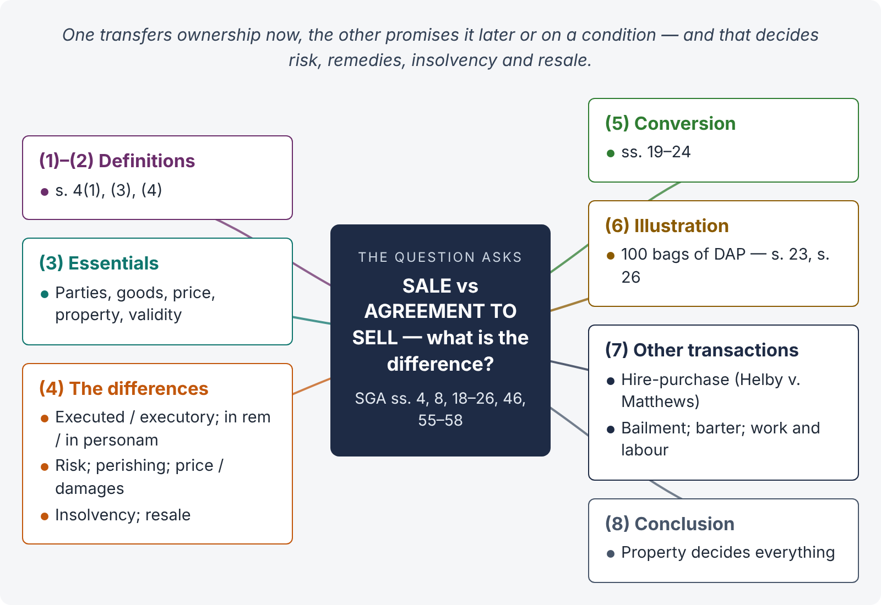
Figure 8 · The answer map: every branch is one numbered heading of the model answer below

Decoding the question
Define both under s. 4, give the essentials of a contract of sale, then distinguish on every point — property, nature of rights, risk, remedies, insolvency, resale, perishing — and show how an agreement to sell becomes a sale (s. 4(4)) through ss. 18–24. Close with how sale differs from hire-purchase and other transactions.

The model answer

1. Introduction
"A contract of sale of goods is a contract whereby the seller transfers or agrees to transfer the property in goods to the buyer for a price" (s. 4(1), SGA 1930). The words "transfers" and "agrees to transfer" mark the two kinds of contract of sale — a sale and an agreement to sell.

2. Definitions — s. 4(3), (4)
"Where under a contract of sale the property in the goods is transferred from the seller to the buyer, the contract is called a sale, but where the transfer of the property in the goods is to take place at a future time or subject to some condition thereafter to be fulfilled, the contract is called an agreement to sell." "An agreement to sell becomes a sale when the time elapses or the conditions are fulfilled subject to which the property in the goods is to be transferred."

3. Essentials of a contract of sale
- Two parties — buyer and seller (a part-owner may sell to another).
- Goods — movables other than actionable claims and money; in Pakistan including electricity, water and gas (s. 2(7)).
- Price — money consideration (s. 2(10)); otherwise barter.
- Transfer or agreement to transfer of ownership ("property" — s. 2(11)).
- All essentials of a valid contract (s. 3; Contract Act s. 10).

4. The differences
Point | Sale | Agreement to sell
Transfer of property | Immediate | Future or conditional
Nature of contract | Executed; a conveyance | Executory; a promise
Nature of right | Jus in rem — the buyer owns the goods against the world | Jus in personam — only a right against the seller
Risk (s. 26) | With the buyer | With the seller
Goods perish | Loss on the buyer (res perit domino) | Agreement avoided if specific goods perish without fault before risk passes (s. 8)
Seller's remedy | Suit for the price (s. 55(1)) | Suit for damages (s. 56), unless price is payable on a day certain (s. 55(2))
Buyer's remedy | As owner, may recover the goods themselves; damages | Damages for non-delivery (s. 57); specific performance for specific / ascertained goods (s. 58)
Seller's insolvency | Buyer claims the goods from the official receiver | Buyer only proves as a creditor
Buyer's insolvency | Seller (if unpaid) may use lien / stoppage (ss. 46–50); otherwise proves for the price | Seller may withhold delivery (s. 46(2))
Resale by seller | Second buyer gets title only under s. 30(1) (seller in possession); otherwise the first buyer can follow the goods | Second buyer gets good title; first buyer sues for damages

5. How an agreement to sell becomes a sale
Property passes when the parties intend (s. 19), guided by the rules in ss. 20–24: unconditional contract for specific goods in a deliverable state — at the time of contract (s. 20); goods to be put into a deliverable state — when that is done and notified (s. 21); price to be ascertained by weighing — when done and notified (s. 22); unascertained goods — on unconditional appropriation with assent (s. 23); goods on approval — on approval or lapse of time (s. 24). Until then, the contract is an agreement to sell.

6. Illustration
On 1 March, Asad agrees to buy "100 bags of DAP fertiliser from your Gujranwala godown" from Bilal, delivery on 15 March. The goods are unascertained — this is an agreement to sell (s. 18). On 10 March Bilal separates 100 bags, marks them "Asad" and Asad's agent approves them — property passes (s. 23) and it becomes a sale. If the godown floods on 12 March, the loss falls on Asad (s. 26). Had the flood occurred on 5 March, before appropriation, the loss would be Bilal's, who must still supply 100 bags from elsewhere.

7. Sale distinguished from other transactions
- Hire-purchase — the hirer has an option to buy and is not bound to buy; until the last instalment, he is a bailee (Helby v. Matthews, [1895] AC 471).
- Bailment — possession only; the same goods are returned (Contract Act s. 148).
- Barter — goods for goods; no money price.
- Contract for work and labour — the substance is skill (Robinson v. Graves, [1935] 1 KB 579 — a portrait).
- Security transactions in the form of a sale — outside the SGA (s. 66(3)).

8. Conclusion
A sale transfers ownership at once; an agreement to sell promises to transfer it in future or on a condition. The distinction governs risk, remedies, insolvency and third-party rights. An agreement to sell becomes a sale when the time passes or the condition is fulfilled, under the rules in ss. 18–24.

Why this answer scores
- It quotes s. 4 precisely and lists the essentials.
- The ten-point table covers every difference examiners look for.
- The illustration shows the moment of conversion (s. 23) and its effect on risk (s. 26).
- It adds the distinction from hire-purchase and other transactions, showing breadth.

Answer 9 · Nemo dat quod non habet — the principle and its exceptions (KPHC 2026)
AT A GLANCE · KP HIGH COURT 2026 · CIVIL LAW-I · PART IV (SALE OF GOODS ACT) · Q. 9 · 20 MARKS
Explain in detail the principle and exceptions to the 'Nemo Dat Quod Non Habet' rule, by quoting relevant law from the Sale of Goods Act, 1930.

The answer map
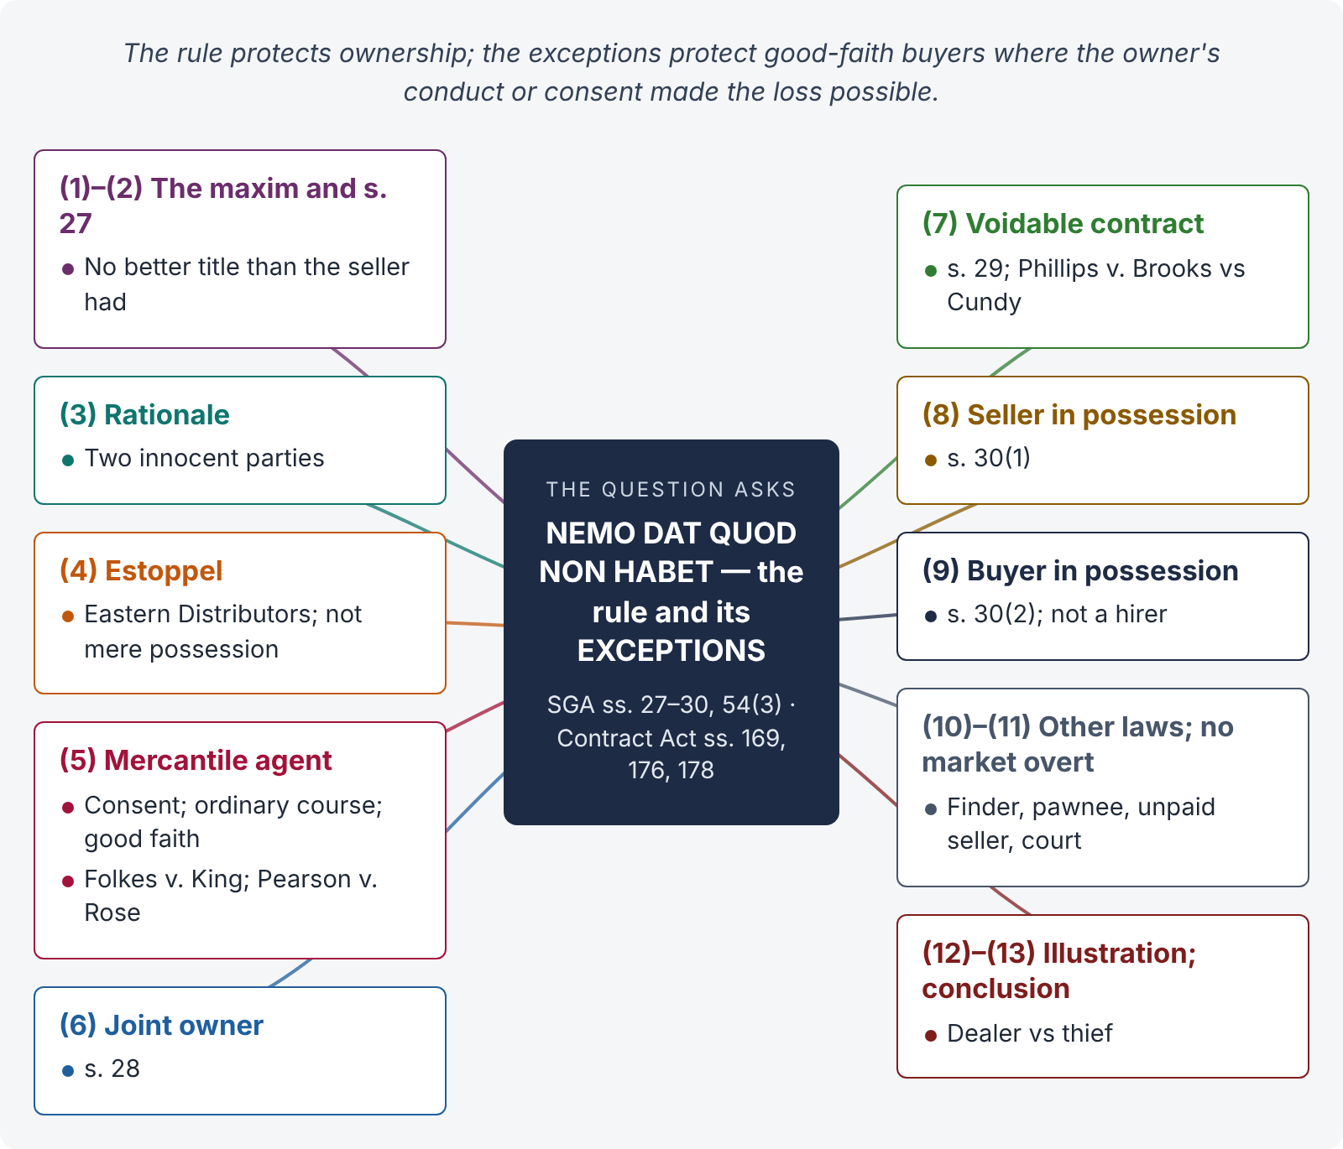
Figure 9 · The answer map: every branch is one numbered heading of the model answer below

Decoding the question
"In detail" and "by quoting relevant law" — so quote s. 27 in full, explain the rationale (the conflict between two innocent parties), and take each exception in turn with its text, conditions and a case: estoppel, mercantile agent, joint owner (s. 28), voidable contract (s. 29), seller in possession (s. 30(1)), buyer in possession (s. 30(2)); then the exceptions under other laws (finder, pawnee, unpaid seller, court sales). Note the absence of market overt in Pakistan.

The model answer

1. Introduction — the maxim
Nemo dat quod non habet — "no one can give what he does not have". A seller who is not the owner of goods, and has no authority from the owner, cannot pass ownership to the buyer. The buyer gets no better title than the seller had.

2. The statutory rule — s. 27
"Subject to the provisions of this Act and of any other law for the time being in force, where goods are sold by a person who is not the owner thereof and who does not sell them under the authority or with the consent of the owner, the buyer acquires no better title to the goods than the seller had, unless the owner of the goods is by his conduct precluded from denying the seller's authority to sell."

3. Rationale — two innocent parties
When a non-owner sells, either the true owner or the innocent buyer must suffer. The rule favours the owner — security of property: a person should not lose his goods without his consent. The exceptions favour the buyer — security of commercial transactions — where the owner has contributed to the deception (by his conduct or by entrusting the goods), or where trade would otherwise be paralysed.

4. Exception 1 — estoppel (s. 27)
The buyer gets a good title where "the owner of the goods is by his conduct precluded from denying the seller's authority to sell". The owner must have represented, by words or conduct, that the seller was the owner or authorised to sell, and the buyer must have acted on it. Eastern Distributors Ltd. v. Goldring ([1957] 2 QB 600): an owner who signed documents enabling a dealer to appear as owner of his van was estopped. Mere possession by the seller, or the owner's carelessness, is not enough (Central Newbury Car Auctions v. Unity Finance, [1957] 1 QB 371).

5. Exception 2 — sale by a mercantile agent (s. 27 proviso)
"Provided that, where a mercantile agent is, with the consent of the owner, in possession of the goods or of a document of title to the goods, any sale made by him, when acting in the ordinary course of business of a mercantile agent, shall be as valid as if he were expressly authorised by the owner of the goods to make the same; provided that the buyer acts in good faith and has not at the time of the contract of sale notice that the seller has not authority to sell."
Conditions: (i) a mercantile agent (s. 2(9)); (ii) in possession of the goods or documents of title with the owner's consent — even consent induced by fraud (Folkes v. King, [1923] 1 KB 282), but in his capacity as mercantile agent (Pearson v. Rose & Young, [1951] 1 KB 275); (iii) sale in the ordinary course of business; (iv) buyer in good faith without notice. The same rule applies to pledges by mercantile agents (Contract Act s. 178).

6. Exception 3 — sale by one of joint owners (s. 28)
"If one of several joint owners of goods has the sole possession of them by permission of the co-owners, the property in the goods is transferred to any person who buys them of such joint owner in good faith and has not at the time of the contract of sale notice that the seller has not authority to sell."

7. Exception 4 — sale by a person in possession under a voidable contract (s. 29)
"When the seller of goods has obtained possession thereof under a contract voidable under section 19 or section 19A of the Contract Act, 1872, but the contract has not been rescinded at the time of the sale, the buyer acquires a good title to the goods, provided he buys them in good faith and without notice of the seller's defect of title."
A seller with a voidable title (obtained by fraud, misrepresentation, coercion or undue influence) can pass good title before the contract is rescinded (Phillips v. Brooks, [1919] 2 KB 243 — the ring obtained by a rogue face to face; Lewis v. Averay, [1972] 1 QB 198). Where the contract is void — e.g., mistake as to the identity of the buyer in a written contract — the rogue has no title to pass (Cundy v. Lindsay, (1878) 3 App Cas 459). The owner can prevent the exception by rescinding promptly, even by informing the police where the rogue has absconded (Car and Universal Finance Co. v. Caldwell, [1965] 1 QB 525).

8. Exception 5 — seller in possession after sale (s. 30(1))
"Where a person, having sold goods, continues or is in possession of the goods or of the documents of title to the goods, the delivery or transfer by that person or by a mercantile agent acting for him, of the goods or documents of title under any sale, pledge or other disposition thereof to any person receiving the same in good faith and without notice of the previous sale shall have the same effect as if the person making the delivery or transfer were expressly authorised by the owner of the goods to make the same."
The first buyer who left the goods with the seller loses to a second buyer who takes delivery in good faith (Pacific Motor Auctions v. Motor Credits, [1965] AC 867, PC). The first buyer sues the seller.

9. Exception 6 — buyer in possession (s. 30(2))
"Where a person, having bought or agreed to buy goods, obtains, with the consent of the seller, possession of the goods or the documents of title to the goods, the delivery or transfer by that person or by a mercantile agent acting for him, of the goods or documents of title under any sale, pledge or other disposition thereof to any person receiving the same in good faith and without notice of any lien or other right of the original seller in respect of the goods shall have effect as if such lien or right did not exist."
A buyer who has not yet acquired property (e.g., the seller reserved title until payment) but has possession with the seller's consent can pass a good title to a bona fide purchaser (Newtons of Wembley v. Williams, [1965] 1 QB 560). A hirer under hire-purchase has not "bought or agreed to buy" and cannot (Helby v. Matthews, [1895] AC 471).

10. Exceptions under other laws ("subject to … any other law")
- Finder of goods — may sell when the goods are perishing or his charges reach two-thirds of their value (Contract Act s. 169).
- Pawnee — may sell on default after reasonable notice (s. 176); pledges by voidable-title holders are valid (s. 178A).
- Unpaid seller — a buyer on resale after lien or stoppage gets good title against the original buyer (SGA s. 54(3)).
- Court and execution sales — the auction-purchaser takes the judgment-debtor's title (CPC O. XXI).
- Negotiable instruments — a holder in due course gets good title (Negotiable Instruments Act ss. 9, 58).
- Official receivers, liquidators and public officers selling under statutory powers.

11. No market overt in Pakistan
English law formerly gave a good title to a buyer in good faith in market overt (an open market). The Pakistani SGA has no such exception; a buyer from a thief in a public market gets no title.

12. Illustration
Rashid entrusts his car to Khalid Motors, a used-car dealer in F-10, to find a buyer at not less than Rs. 5 million. Khalid sells it to Naveed, who pays Rs. 4.8 million in good faith at the showroom. Naveed gets good title: Khalid is a mercantile agent in possession with the owner's consent, selling in the ordinary course of business to a bona fide buyer (s. 27 proviso); Rashid's remedy is against Khalid. But if a thief had stolen the car from Rashid's driveway and sold it to Naveed through the same showroom, nemo dat would apply — Naveed would get no title.

13. Conclusion
The rule in s. 27 protects ownership: a non-owner without authority passes no title. The exceptions protect commerce where the owner's own conduct or consent made the fraud possible — estoppel, mercantile agents, joint owners, voidable titles, sellers and buyers in possession (ss. 27–30) — and where other laws authorise sale (finders, pawnees, unpaid sellers, courts). Each exception requires the buyer to act in good faith and without notice.

Why this answer scores
- It quotes each provision, as the question demands.
- Every exception has its conditions and a leading case.
- It explains the rationale (two innocent parties) that ties the exceptions together.
- The illustration contrasts an exception (mercantile agent) with the rule (stolen goods).

Answer 10 · Delivery — definition, types and rules (KPHC 2026)
AT A GLANCE · KP HIGH COURT 2026 · CIVIL LAW-I · PART IV (SALE OF GOODS ACT) · Q. 10 · 20 MARKS
How does the Sale of Goods Act, 1930, define 'delivery'? What are its types and different rules?

The answer map
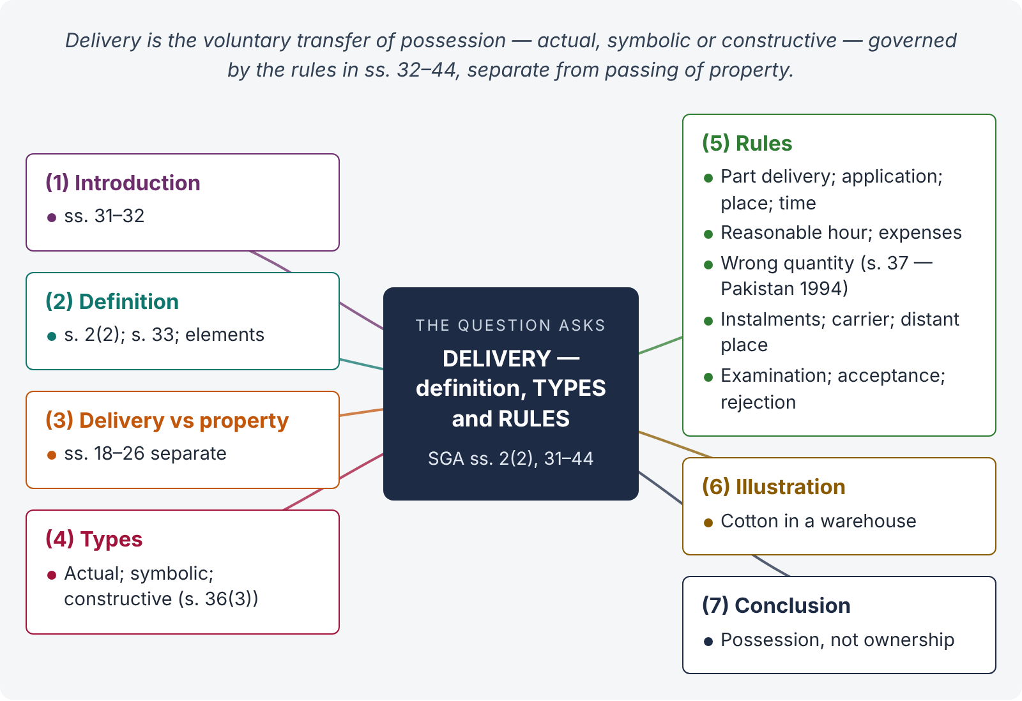
Figure 10 · The answer map: every branch is one numbered heading of the model answer below

Decoding the question
Three parts: definition (s. 2(2) with s. 33); types (actual, symbolic, constructive — with s. 36(3)); rules (ss. 31–44 — concurrent conditions, part delivery, application, place, time, third persons, reasonable hour, expenses, wrong quantity, instalments, carrier, distant place, examination, acceptance, rejection). Distinguish delivery (possession) from transfer of property.

The model answer

1. Introduction
The seller's main duty is "to deliver the goods" and the buyer's "to accept and pay for them" (s. 31). "Unless otherwise agreed, delivery of the goods and payment of the price are concurrent conditions" (s. 32).

2. Definition
"Delivery" means "voluntary transfer of possession from one person to another" (s. 2(2)). Section 33 adds: "Delivery of goods sold may be made by doing anything which the parties agree shall be treated as delivery or which has the effect of putting the goods in the possession of the buyer or of any person authorised to hold them on his behalf."
Elements: (i) a transfer of possession (not ownership); (ii) it must be voluntary — goods taken by the buyer without the seller's consent are not delivered; (iii) to the buyer or his authorised agent.

3. Delivery and transfer of property distinguished
Delivery passes possession; the passing of property (ownership) is governed by ss. 18–26 and depends on the parties' intention. Property may pass before delivery (s. 20 — specific goods in a deliverable state) and delivery may occur before property passes (s. 25 — reservation of the right of disposal; goods on approval, s. 24).

4. Types of delivery

i) Actual delivery
Physical handing over of the goods to the buyer or his agent — the shopkeeper hands over the goods at the counter.

ii) Symbolic delivery
Handing over something that gives control of the goods: the keys of a godown; a document of title (bill of lading, railway receipt, warehouse receipt — s. 2(4)); the registration documents and keys of a vehicle.

iii) Constructive delivery (attornment)
No physical change, but the person in possession acknowledges that he holds the goods for another: (a) the seller, after sale, agrees to hold as the buyer's bailee; (b) the buyer, already in possession as bailee, now holds as owner; (c) a third person in possession (a warehouseman) acknowledges to the buyer that he holds for him — "where the goods at the time of sale are in the possession of third persons, there is no delivery by seller to buyer unless and until such third person acknowledges to the buyer that he holds the goods on his behalf" (s. 36(3)).

5. Rules as to delivery
- Concurrent conditions — delivery and payment go together (s. 32).
- Part delivery — in progress of delivery of the whole, it has the effect of delivery of the whole for passing property; but not if intended to sever the part from the whole (s. 34).
- Buyer to apply — apart from express contract, the seller need not deliver until the buyer applies (s. 35).
- Place — as agreed; otherwise goods sold are delivered where they are at the time of sale; goods agreed to be sold, where they are at the time of the agreement, or where manufactured or produced (s. 36(1)).
- Time — if the seller must send the goods and no time is fixed, within a reasonable time (s. 36(2)).
- Goods with a third person — attornment required; documents of title operate normally (s. 36(3)).
- Reasonable hour — demand or tender at an unreasonable hour may be treated as ineffectual (s. 36(4)).
- Expenses — of putting the goods into a deliverable state are borne by the seller (s. 36(5)).
- Wrong quantity — s. 37: short delivery — buyer may reject, or accept and pay pro rata at the contract rate; excess — accept the contract quantity and reject the rest, or (in Pakistan, where separation is difficult or time consuming — 1994 amendment) reject the whole; mixed goods — accept the conforming goods and reject the rest, or reject all; all subject to usage, agreement and course of dealing.
- Instalments — s. 38: the buyer is not bound to accept delivery by instalments unless agreed; in instalment contracts, whether a defective instalment is a repudiation of the whole or a severable breach depends on the terms and circumstances (Maple Flock Co. v. Universal Furniture Products, [1934] 1 KB 148).
- Delivery to a carrier or wharfinger — prima facie delivery to the buyer (s. 39(1)); the seller must make a reasonable contract with the carrier (s. 39(2)); for sea transit, notice to enable the buyer to insure (s. 39(3)).
- Distant place — where the seller agrees to deliver at his risk elsewhere, the buyer still bears the risk of deterioration necessarily incident to transit (s. 40).
- Examination — s. 41: the buyer is not deemed to accept until he has had a reasonable opportunity to examine the goods.
- Acceptance — s. 42: by intimation, by an act inconsistent with the seller's ownership, or by retention beyond a reasonable time without rejection.
- Rejection — s. 43: the buyer need not return rejected goods; intimation of refusal is enough.
- Buyer's failure to take delivery — s. 44: liable for loss and a reasonable charge for care and custody.

6. Illustration
Zafar buys 200 bales of cotton lying in Pak Warehouse, Faisalabad, from Yousaf. Yousaf hands Zafar a delivery order addressed to the warehouse. Delivery is not complete until the warehouse-keeper acknowledges to Zafar that he holds the bales for him (s. 36(3)) — unless the delivery order is a document of title transferred in the usual way. If Yousaf delivers 220 bales mixed in a way that makes separation difficult, Zafar may reject the whole (s. 37(2) as amended in Pakistan).

7. Conclusion
Delivery is the voluntary transfer of possession (s. 2(2)), effected by anything agreed or that puts the goods in the buyer's possession (s. 33) — actually, symbolically or constructively (s. 36(3)). The rules in ss. 32–44 settle the place, time, manner, quantity, instalments, carriage, examination and acceptance, and they operate separately from the rules on passing of property.

Why this answer scores
- Definition from s. 2(2) and s. 33, with its elements.
- Three types, each with examples, and s. 36(3) for attornment.
- A complete numbered list of rules with sections, including the Pakistani s. 37(2) amendment.
- It distinguishes delivery from property — the conceptual point examiners look for.

Answer 11 · Caveat emptor — the doctrine and its exceptions (PU LL.B)
AT A GLANCE · PUNJAB UNIVERSITY LL.B PART III · LAW OF CONTRACT · 2020 (ANNUAL) · Q. 9 · 20 MARKS
What do you understand by the phrase "Doctrine of Caveat Emptor"? Explain the exceptions to this doctrine in the light of relevant provisions of the Sale of Goods Act, 1930.

The answer map
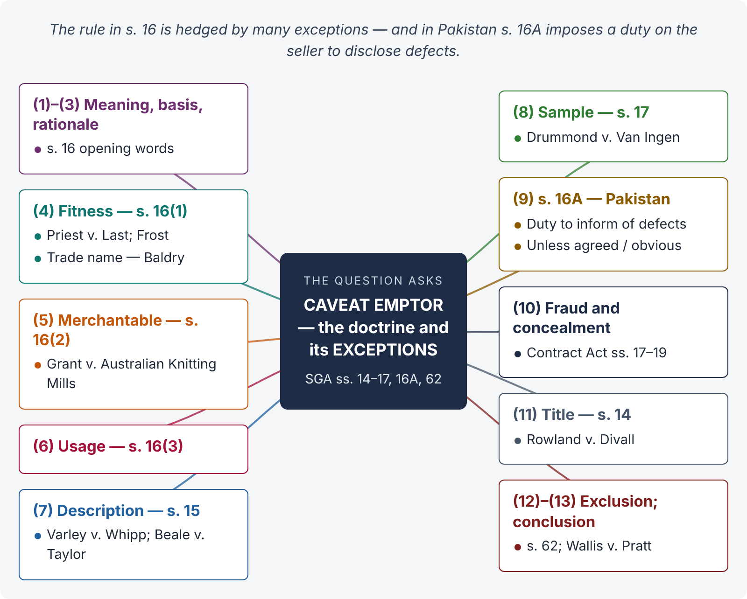
Figure 11 · The answer map: every branch is one numbered heading of the model answer below

Decoding the question
State the doctrine (s. 16's opening words), its rationale, and then every exception — fitness for purpose, merchantable quality, usage, description, sample, title, fraud — with cases. The Pakistani candidate must add s. 16A (1994), which imposes a duty to disclose defects and reshapes the doctrine in Pakistan.

The model answer

1. Meaning
Caveat emptor means "let the buyer beware". The buyer must examine the goods and judge their quality and suitability for himself; if he buys goods that turn out defective or unsuitable, he cannot hold the seller responsible — unless the seller gave a warranty, committed fraud, or the law implies a term.

2. Statutory basis — s. 16 (opening words)
"Subject to the provisions of this Act and of any other law for the time being in force, there is no implied warranty or condition as to the quality or fitness for any particular purpose of goods supplied under a contract of sale, except as follows …" The rule is thus stated together with its exceptions.

3. Rationale
The buyer is best placed to decide what he wants and to inspect what he buys; the seller cannot be an insurer of every buyer's purpose. The rule promotes certainty and self-reliance in commerce. But modern trade — complex goods, latent defects, reliance on sellers' expertise — has led the law to qualify it heavily.

4. Exception 1 — fitness for a particular purpose — s. 16(1)
Where the buyer makes known (expressly or by implication) the particular purpose, so as to show that he relies on the seller's skill or judgment, and the goods are of a description the seller deals in, there is an implied condition that they are reasonably fit for that purpose. Priest v. Last ([1903] 2 KB 148 — a hot-water bottle that burst); Frost v. Aylesbury Dairy ([1905] 1 KB 608 — milk with typhoid germs; strict liability).
Proviso — trade name: no implied condition of fitness for a specified article sold under its patent or trade name — but only where the buyer does not rely on the seller (Baldry v. Marshall, [1925] 1 KB 260 — reliance on the seller's recommendation of a Bugatti).

5. Exception 2 — merchantable quality — s. 16(2)
Where goods are bought by description from a seller who deals in such goods, there is an implied condition that they are of merchantable quality — saleable as goods of that description at the normal price. If the buyer examined the goods, there is no condition as to defects that examination ought to have revealed; but latent defects remain covered (Grant v. Australian Knitting Mills, [1936] AC 85, PC — woollen underwear with hidden sulphites).

6. Exception 3 — usage of trade — s. 16(3)
An implied condition or warranty as to quality or fitness may be annexed by usage of trade.

7. Exception 4 — sale by description — s. 15
Goods sold by description must correspond with the description (Varley v. Whipp, [1900] 1 QB 513; Beale v. Taylor, [1967] 1 WLR 1193). If by sample and description, they must correspond with both.

8. Exception 5 — sale by sample — s. 17
Implied conditions that the bulk corresponds with the sample, that the buyer has a reasonable opportunity to compare, and that the goods are free from defects rendering them unmerchantable that would not be apparent on reasonable examination of the sample (Drummond v. Van Ingen (1887) 12 App Cas 284).

9. Exception 6 — Pakistan's s. 16A: the duty to disclose defects
"16A. Notwithstanding anything contained in section 16, and save where the parties have entered into an agreement to the contrary, the seller shall be under an obligation to inform the buyer of any defect in the goods sold at the time of the contract, except in a case where the defect is obviously known to the buyer." (Act XVIII of 1994.)
- It applies "notwithstanding" s. 16 — it overrides the general rule of caveat emptor as to disclosure.
- The seller must inform the buyer of defects at the time of the contract — silence is no longer safe for a Pakistani seller.
- Exceptions: an agreement to the contrary (e.g., an "as is where is" sale), and defects obviously known to the buyer.
- Effect: non-disclosure is a breach of a statutory duty, giving the buyer a remedy in damages (and rejection where the defect goes to the root), and is strong evidence of fraud by concealment (Contract Act s. 17).
- It brings the law into line with the Islamic principle of khiyar al-'aib (option for defect).

10. Exception 7 — fraud, misrepresentation and active concealment
Caveat emptor never protects a seller who misrepresents the goods or actively conceals defects (Contract Act ss. 17–19, applied by SGA s. 3). Illustration (d) to s. 19, Contract Act: concealment of a vein of ore makes the contract voidable.

11. Exception 8 — implied terms as to title — s. 14
Caveat emptor applies to quality, not title: the seller impliedly undertakes that he has a right to sell, and warrants quiet possession and freedom from encumbrances (Rowland v. Divall, [1923] 2 KB 500).

12. Exclusion
Implied terms may be excluded by express agreement, course of dealing or usage (s. 62), but exclusion clauses are construed strictly (Wallis v. Pratt, [1911] AC 394 — excluding "warranties" does not exclude conditions), and consumer protection laws may forbid unfair exclusions.

13. Conclusion
Caveat emptor remains the starting point (s. 16): the law implies no term as to quality or fitness. But the exceptions — fitness for a made-known purpose, merchantable quality, usage, description, sample, title and fraud — have reduced it to a rule for the careless buyer who neither relies on the seller nor inspects. In Pakistan, s. 16A goes further and requires the seller to disclose defects, so that the maxim is better stated as caveat venditor — let the seller beware — wherever he knows of a defect.

Why this answer scores
- It states the doctrine from the statute and gives its rationale.
- Every exception has its section and leading case.
- It highlights s. 16A — the Pakistani provision most candidates do not know.
- The conclusion evaluates the doctrine's current strength rather than just listing.

Answer 12 · Who is an unpaid seller? His rights against the goods (PU LL.B)
AT A GLANCE · PUNJAB UNIVERSITY LL.B PART III · LAW OF CONTRACT · 2018 AND 2019 (SUPPLEMENTARY) · Q. 10 · 20 MARKS
Who is an "unpaid seller"? What are his rights against the goods provided in the Sale of Goods Act?

The answer map
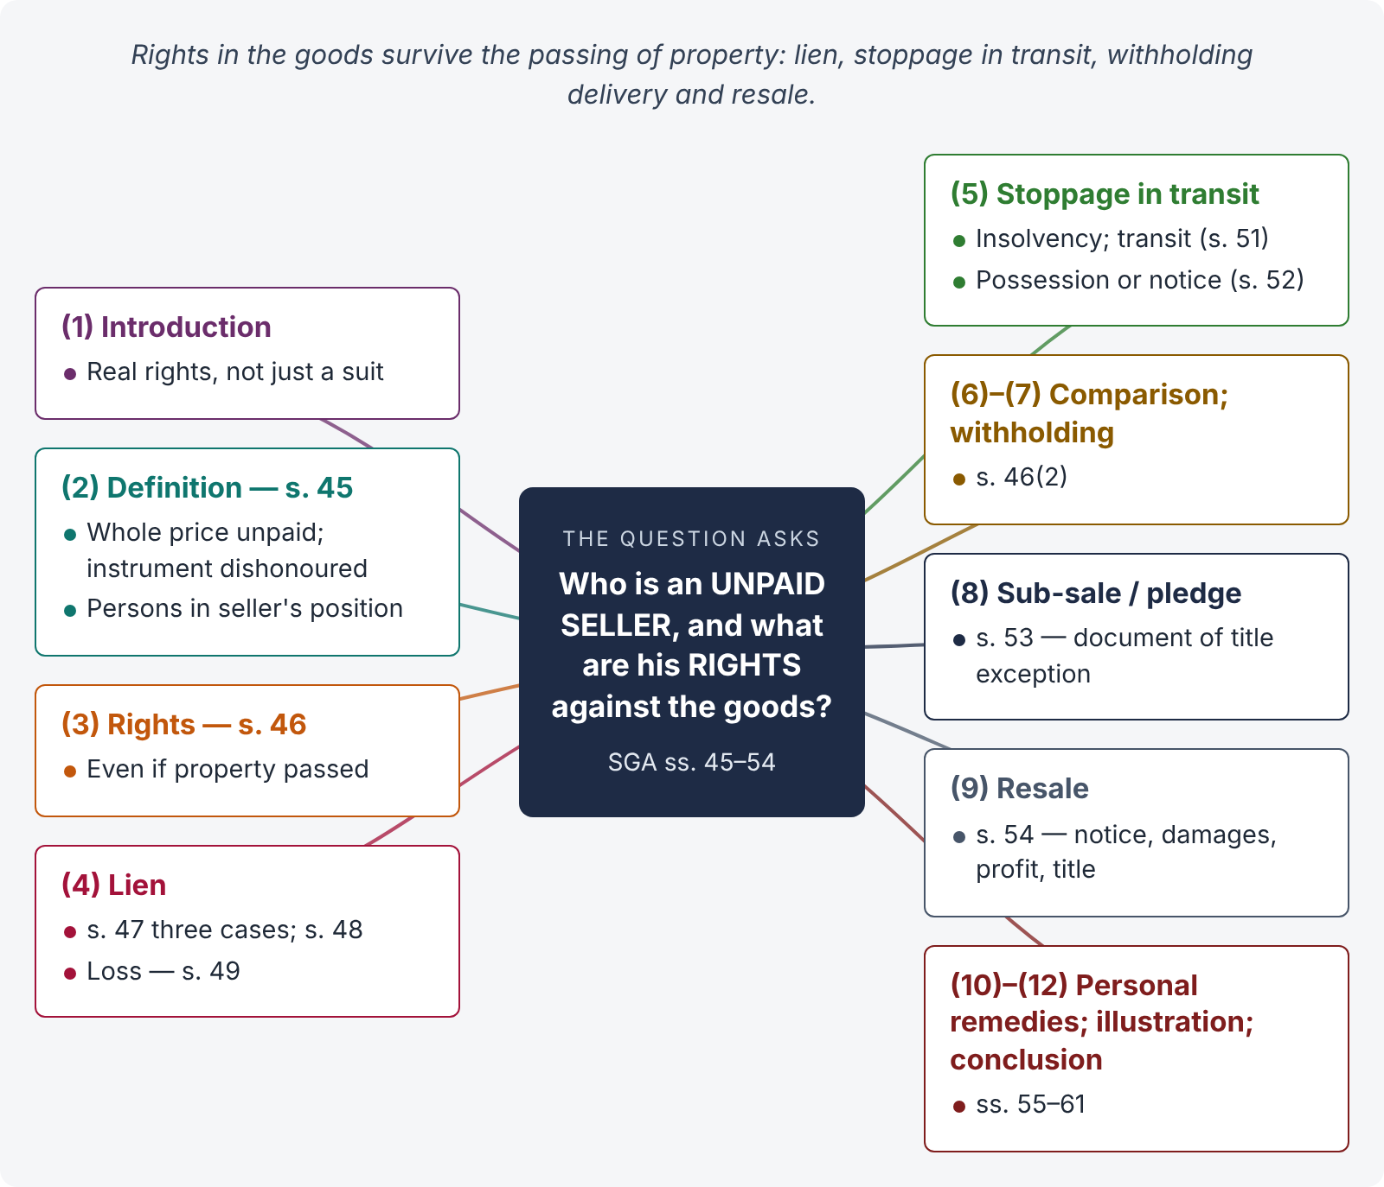
Figure 12 · The answer map: every branch is one numbered heading of the model answer below

Decoding the question
Define the unpaid seller (s. 45); then his rights against the goods (s. 46) — lien (ss. 47–49), stoppage in transit (ss. 50–52), withholding delivery (s. 46(2)), resale (s. 54) — with conditions, termination, and the effect of a sub-sale or pledge by the buyer (s. 53). A comparison table of lien and stoppage, and a brief note of his personal remedies, finishes the answer.

The model answer

1. Introduction
A seller who has parted with his goods, or agreed to, but has not been paid, would be at the mercy of the buyer's solvency if his only remedy were a suit for the price. The SGA gives him real rights over the goods themselves.

2. Who is an unpaid seller — s. 45
The seller is deemed an "unpaid seller" — (a) "when the whole of the price has not been paid or tendered"; (b) "when a bill of exchange or other negotiable instrument has been received as conditional payment, and the condition on which it was received has not been fulfilled by reason of the dishonour of the instrument or otherwise" (s. 45(1)). "Seller" includes any person in the position of a seller — an agent to whom the bill of lading has been endorsed, or a consignor or agent who has paid or is responsible for the price (s. 45(2)). Part payment does not end his status.

3. His rights — s. 46
"Notwithstanding that the property in the goods may have passed to the buyer, the unpaid seller of goods, as such, has by implication of law— (a) a lien on the goods for the price while he is in possession of them; (b) in case of the insolvency of the buyer a right of stopping the goods in transit after he has parted with the possession of them; (c) a right of re-sale as limited by this Act" (s. 46(1)). "Where the property in goods has not passed to the buyer, the unpaid seller has, in addition to his other remedies, a right of withholding delivery similar to and co-extensive with his rights of lien and stoppage in transit" (s. 46(2)).

4. Right 1 — lien (ss. 47–49)
- When — s. 47(1): the unpaid seller in possession may retain the goods until payment or tender of the price (a) where sold without any stipulation as to credit; (b) where sold on credit but the credit has expired; (c) where the buyer becomes insolvent.
- Even if he holds as the buyer's agent or bailee (s. 47(2)).
- Part delivery — lien on the remainder unless the part delivery shows a waiver (s. 48).
- Loss of lien — s. 49: (a) delivery to a carrier for transmission to the buyer without reserving the right of disposal; (b) the buyer or his agent lawfully obtains possession; (c) waiver. Not lost merely by obtaining a decree for the price (s. 49(2)).
- It is for the price only, not for storage or other charges.

5. Right 2 — stoppage in transit (ss. 50–52)
- When — s. 50: the buyer becomes insolvent, and the unpaid seller who has parted with possession may resume possession while the goods are in transit, and retain them until payment.
- Duration of transit — s. 51: from delivery to a carrier until the buyer or his agent takes delivery; ends on delivery before arrival, or on the carrier's acknowledgment after arrival that he holds for the buyer; continues if the buyer rejects the goods; ends if the carrier wrongfully refuses delivery; after part delivery, the rest may be stopped.
- How — s. 52: by taking actual possession, or by notice to the carrier (or his principal, in time to prevent delivery); the carrier must re-deliver to the seller at the seller's expense.

6. Lien and stoppage compared
Point | Lien | Stoppage in transit
Possession | Seller keeps it | Seller has parted with it and resumes it
Buyer's insolvency | Not required | Essential
Starts / ends | Ends when goods go to the carrier or buyer | Begins where lien ends; ends when transit ends
Nature | Right to retain | Right to regain

7. Right 3 — withholding delivery (s. 46(2))
Where property has not passed, the unpaid seller may simply withhold delivery, with rights co-extensive with lien and stoppage.

8. Effect of a sub-sale or pledge by the buyer — s. 53
The seller's lien or stoppage is not affected by the buyer's sale or other disposition unless the seller assented (s. 53(1)). Except: where a document of title has been lawfully transferred to the buyer and he transfers it to a person who takes in good faith and for consideration — a sale defeats the seller's right; a pledge leaves it exercisable only subject to the pledgee's rights, and the seller may require the pledgee first to resort to the buyer's other securities (s. 53(2)).

9. Right 4 — resale (s. 54)
- No rescission by lien or stoppage alone (s. 54(1)).
- Where the goods are perishable, or the seller gives notice of intention to resell and the buyer does not pay within a reasonable time, the seller may resell and recover damages for any loss; the buyer gets no profit (s. 54(2)).
- If no notice is given (for non-perishables), the seller cannot recover damages and the buyer is entitled to any profit (s. 54(2)).
- The second buyer gets a good title against the original buyer, notice or not (s. 54(3)).
- Where the seller expressly reserved a right of resale on default and resells, the original contract is rescinded, without prejudice to damages (s. 54(4)).

10. Personal remedies (in brief)
Besides rights against the goods, the unpaid seller may sue for the price (s. 55), for damages for non-acceptance (s. 56), for damages on anticipatory repudiation (s. 60), and for interest (s. 61).

11. Illustration
Sadiq sells 500 bales of cloth to Rehman on 30 days' credit and sends them by goods train. Rehman becomes insolvent while the goods are in transit. Sadiq has no lien (he parted with possession to the carrier — s. 49(1)(a)) but may stop the goods in transit by notice to the railway (ss. 50–52). He then gives Rehman notice of resale and, if not paid within a reasonable time, resells and claims any shortfall as damages (s. 54(2)); the new buyer gets good title (s. 54(3)).

12. Conclusion
An unpaid seller is one who has not received or been tendered the whole price, or whose negotiable instrument has been dishonoured (s. 45). Against the goods he has a lien while in possession, a right of stoppage in transit on the buyer's insolvency, a right to withhold delivery where property has not passed, and a limited right of resale — rights that survive even the passing of property, and are defeated only by his own assent or by a bona fide transfer of a document of title.

Why this answer scores
- It defines the unpaid seller precisely, including the dishonoured instrument and persons in the seller's position.
- Each right has its conditions, termination and section.
- The comparison table and the s. 53 exception show depth.
- The illustration walks through lien → stoppage → resale in order.

